Lancaster Seventh-Day Adventist Church
A House of Prayer for All People

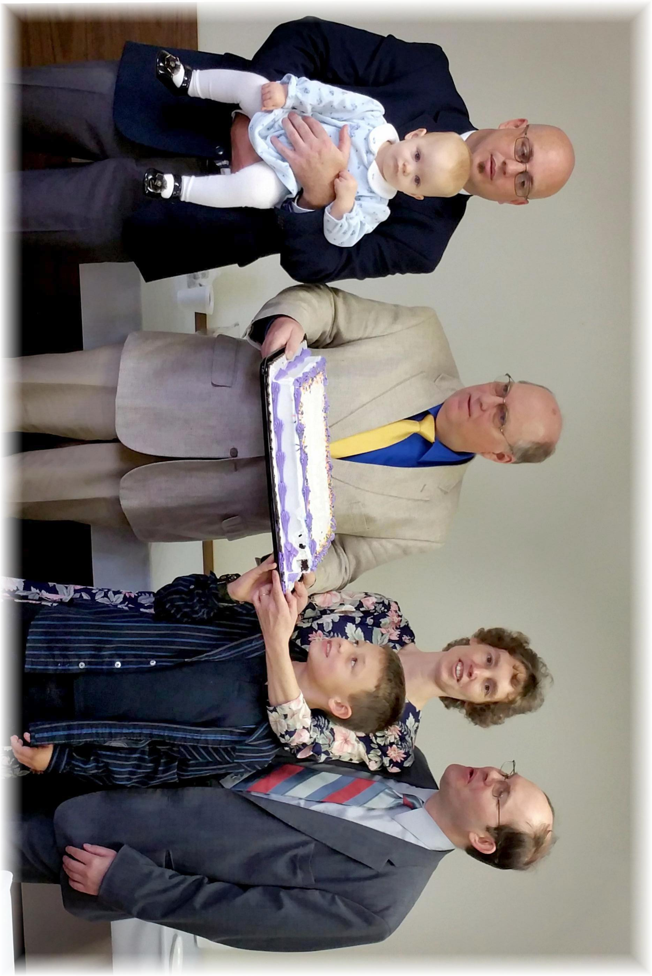
November Birthdays and Anniversary - 2015

