Lancaster Seventh-Day Adventist Church
A House of Prayer for All People

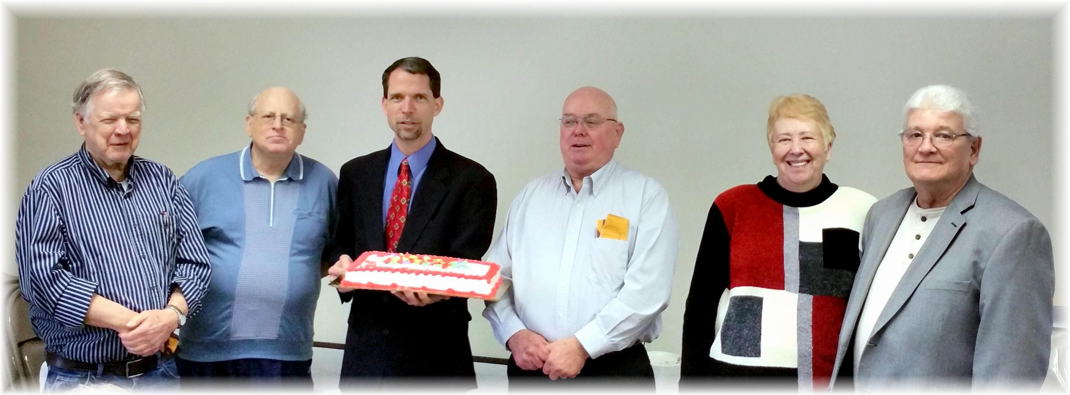
December Birthdays and Anniversary - 2015

