Lancaster Seventh-Day Adventist Church
A House of Prayer for All People

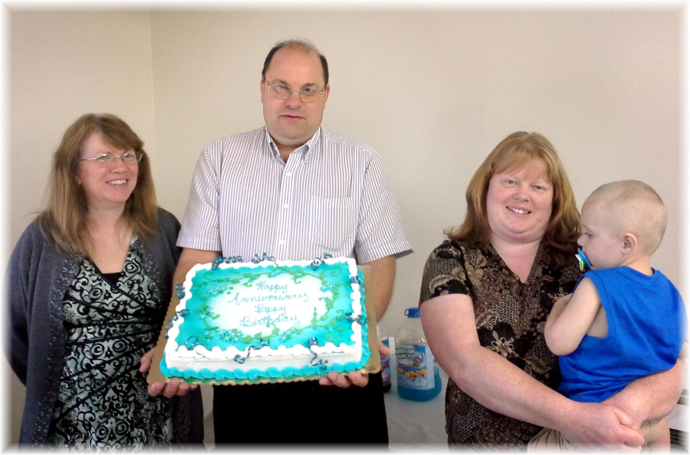
Anniversary and Birthdays – June, 2015

