Lancaster Seventh-Day Adventist Church
A House of Prayer for All People

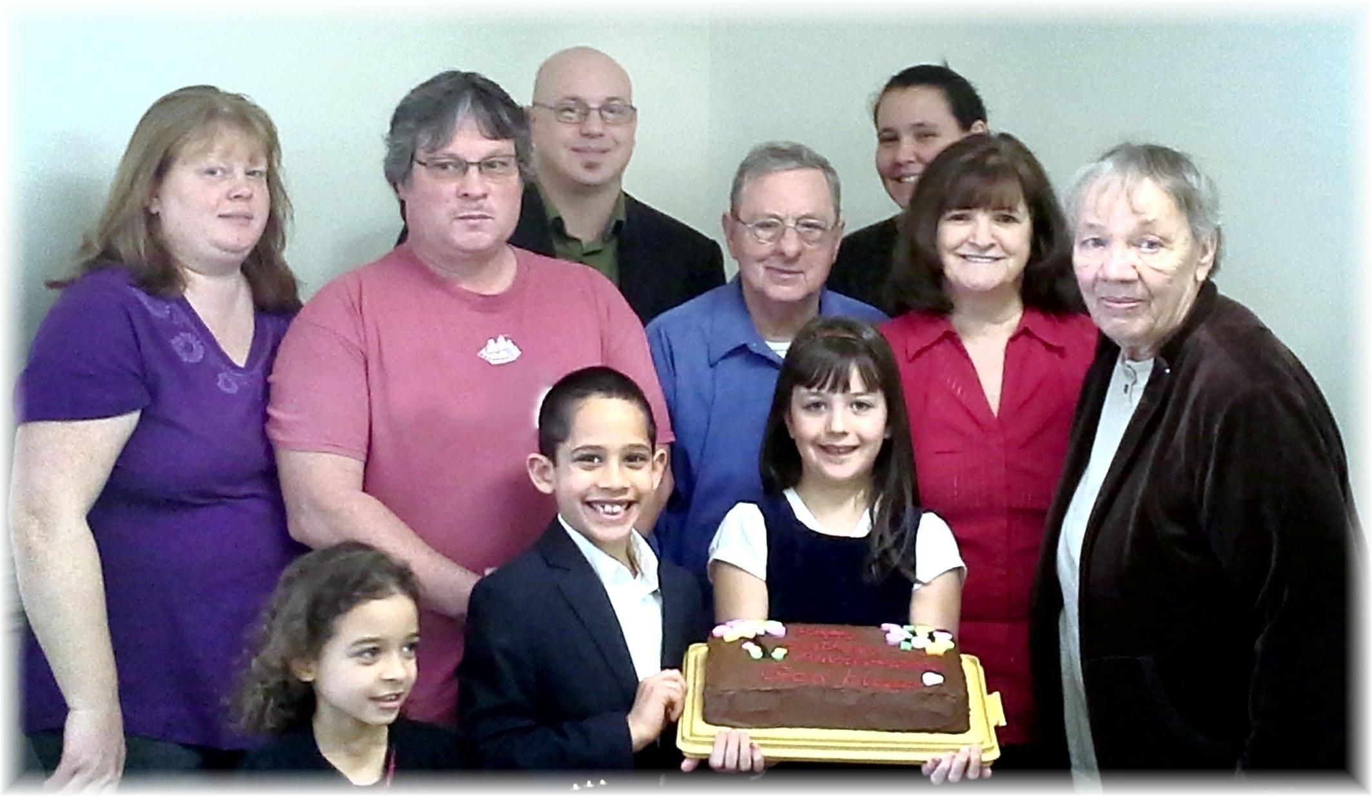
February Anniversaries and Birthdays - 2015

