Lancaster Seventh-Day Adventist Church
A House of Prayer for All People

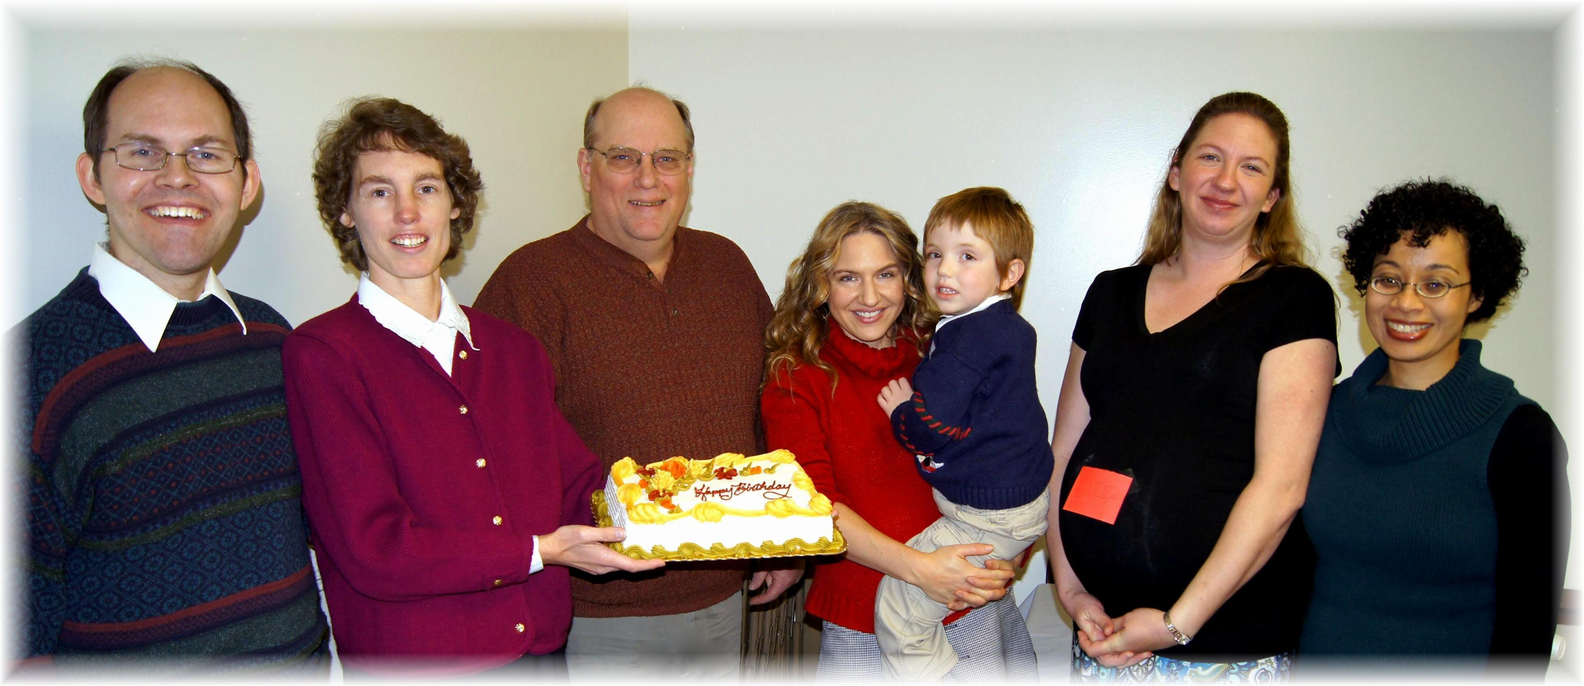
Anniversary: James & Connie Birthdays: Eldon, Jesse (with Trina), Lydia (in Jennifer), Cesilia
November Anniversary and Birthdays - 2014

