Lancaster Seventh-Day Adventist Church
A House of Prayer for All People

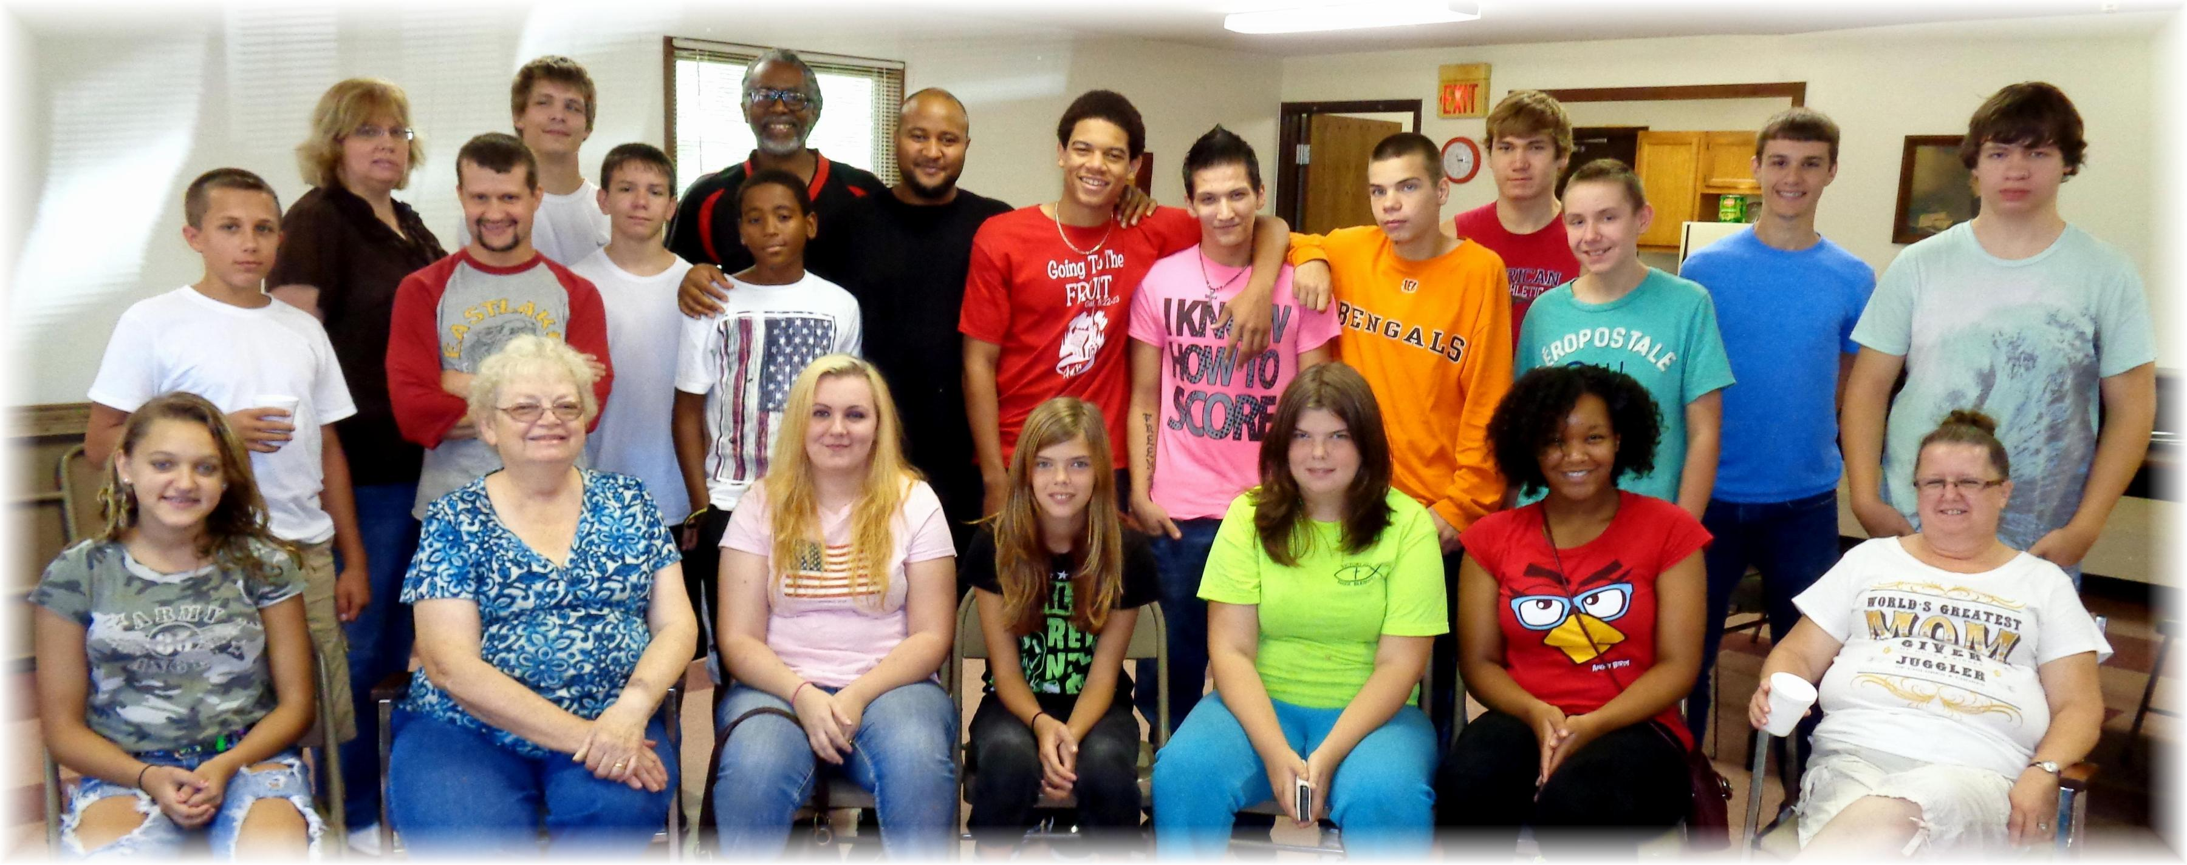
Lancaster SDA & Fruit of the Spirit Church Youth Social – Sept. 21, 2014

