Lancaster Seventh-Day Adventist Church
A House of Prayer for All People

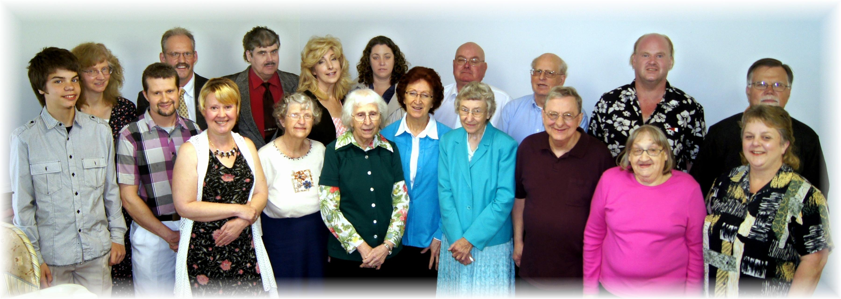
Ohio Adventist Singles meet at Lancaster – May 10, 2014

