Lancaster Seventh-Day Adventist Church
A House of Prayer for All People

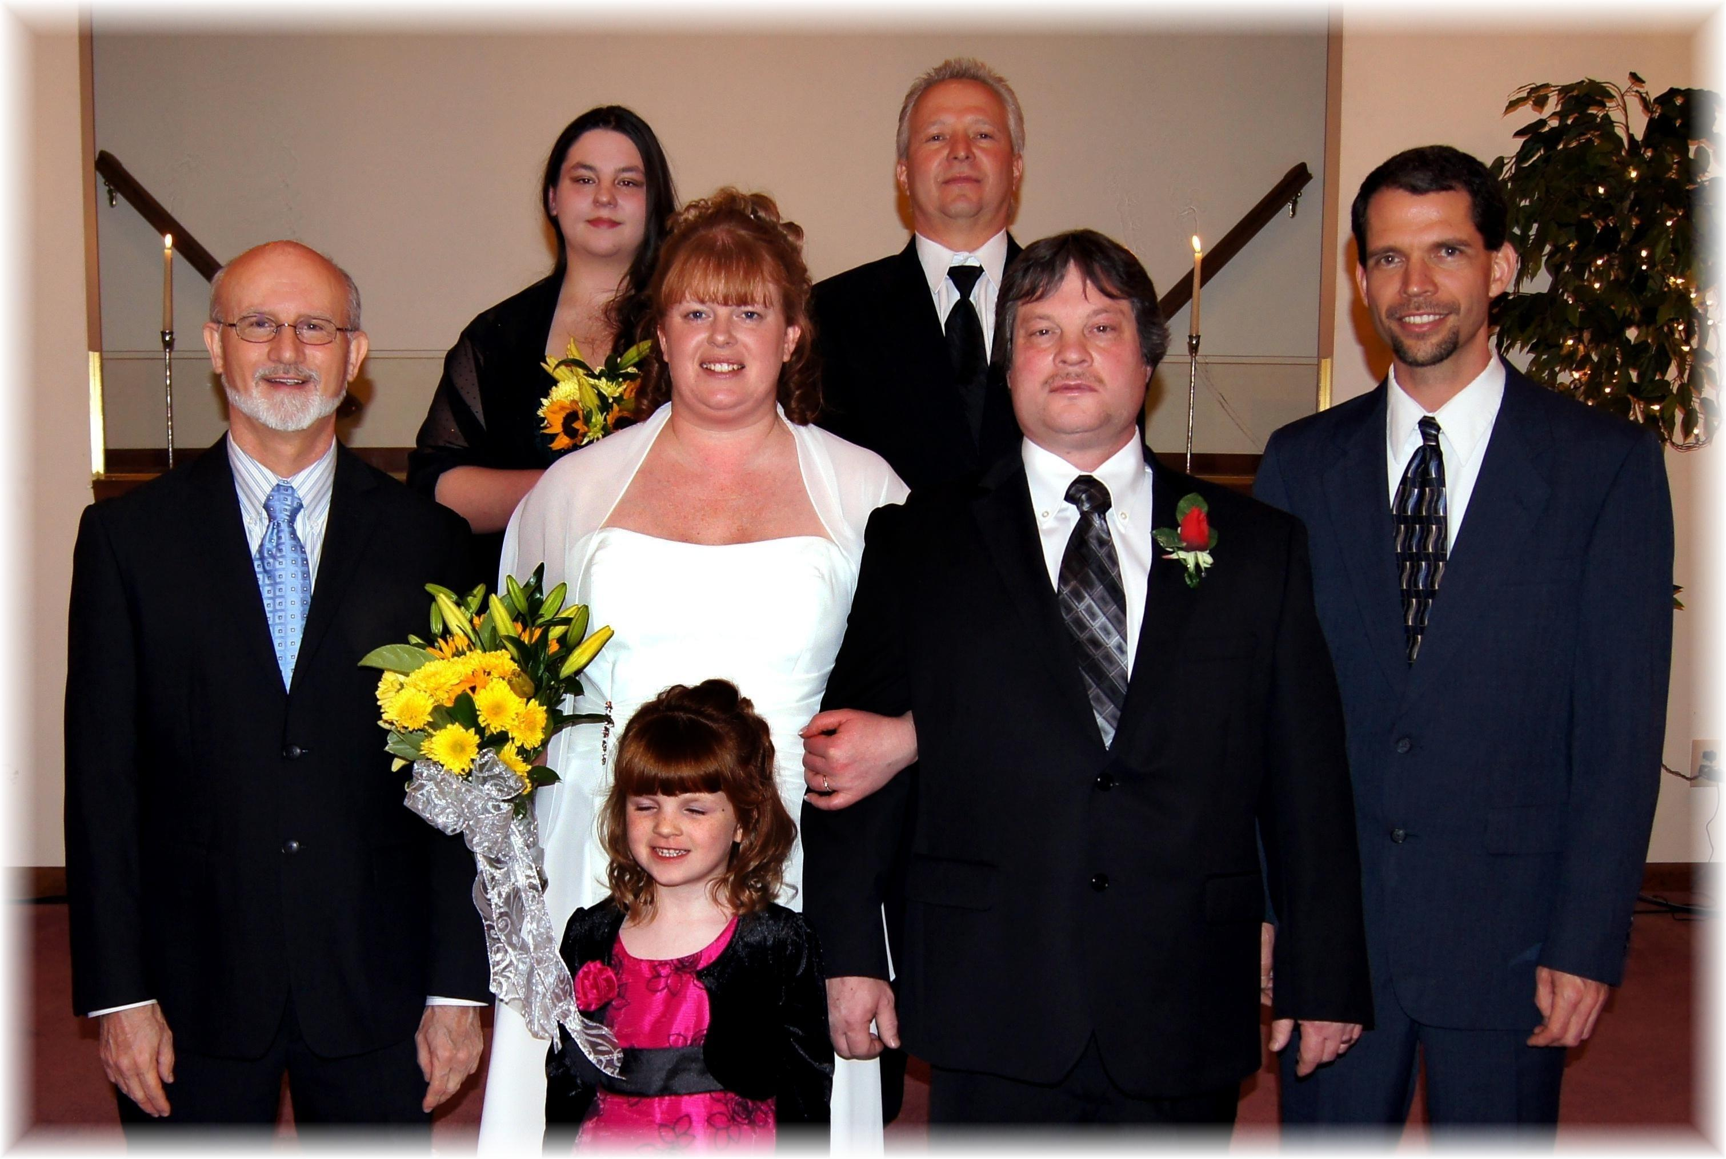
Tami & Jim Nichols Wedding – February 4, 2012

