Lancaster Seventh-Day Adventist Church
A House of Prayer for All People

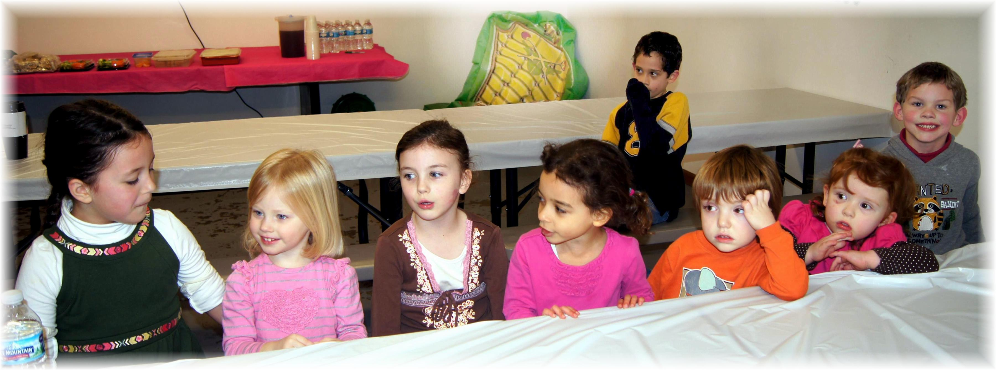
Callie, Chloe, Alena, Abigail, Elijah (in back), Jesse, Luci, Andrew
Jolly Hoppers - January 16, 2014

