Lancaster Seventh-Day Adventist Church
A House of Prayer for All People

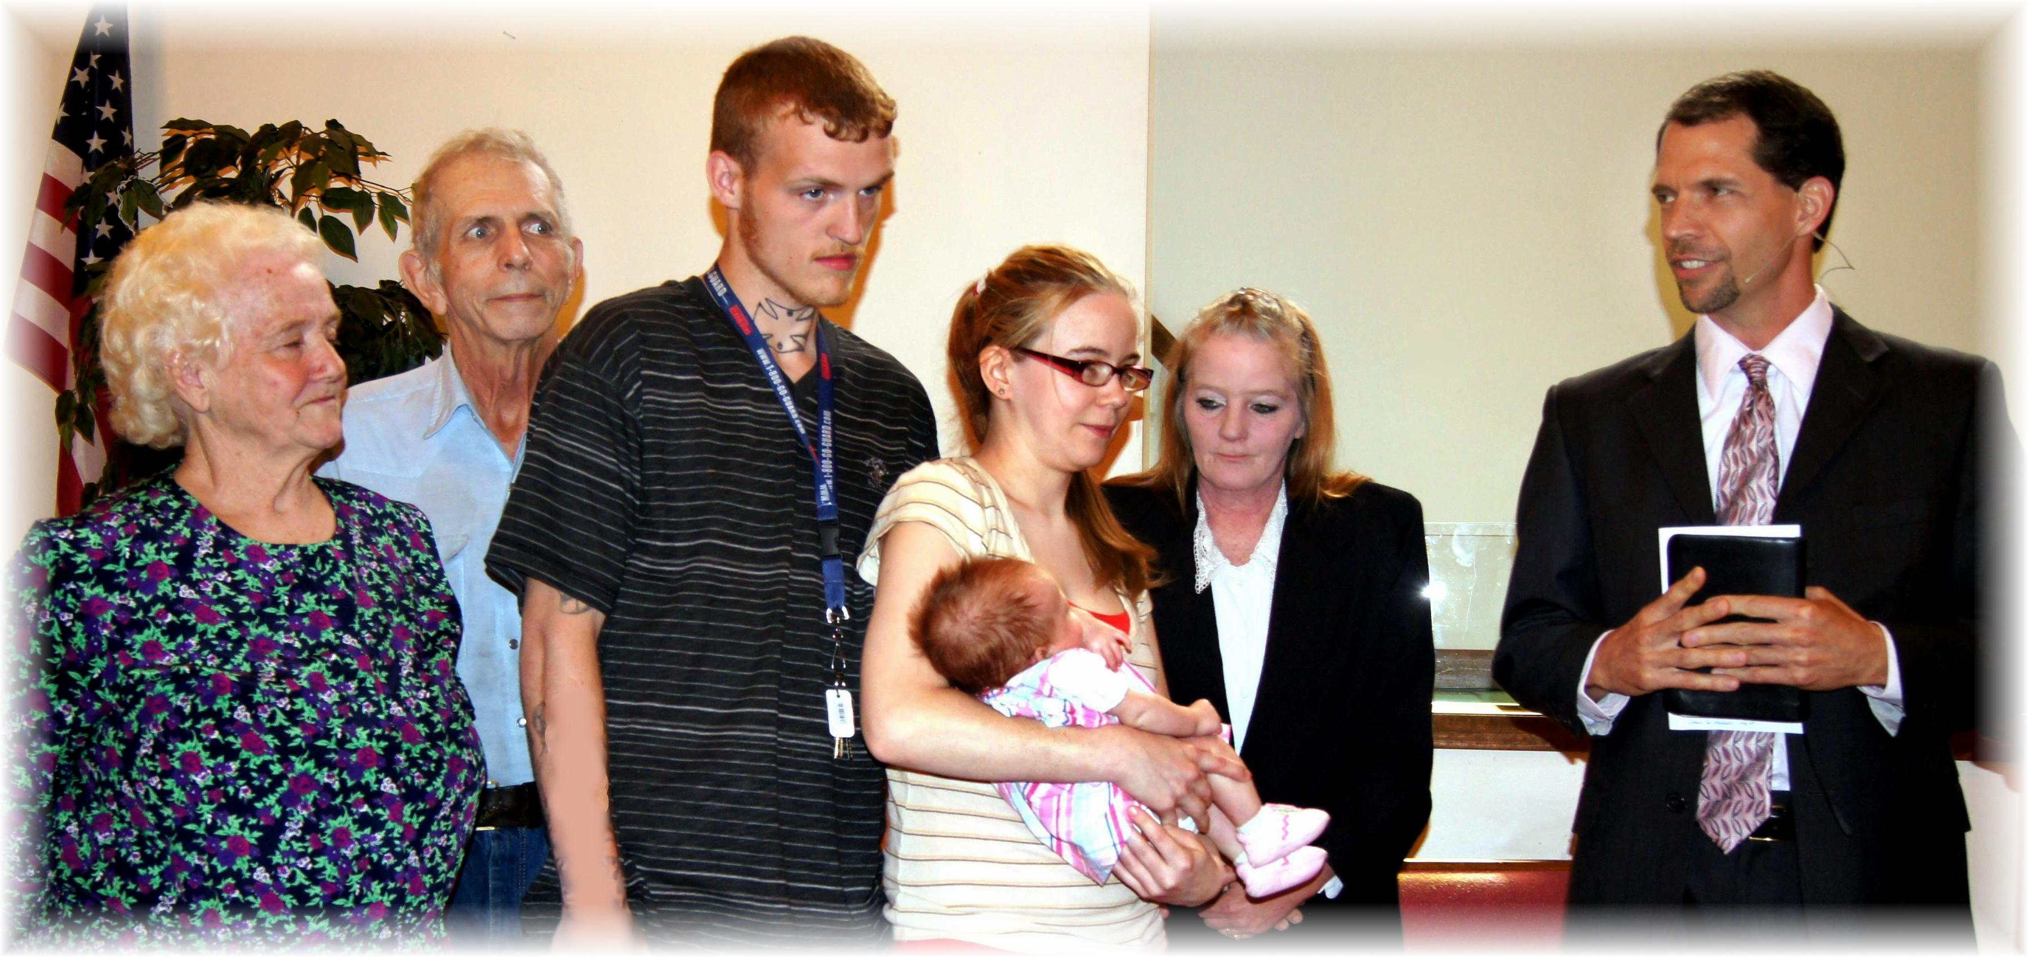
Sandy, John, Will, Stephanie with baby Zoey, Lori, Travis
Baby Dedication – May 4, 2013

