Lancaster Seventh-Day Adventist Church
A House of Prayer for All People

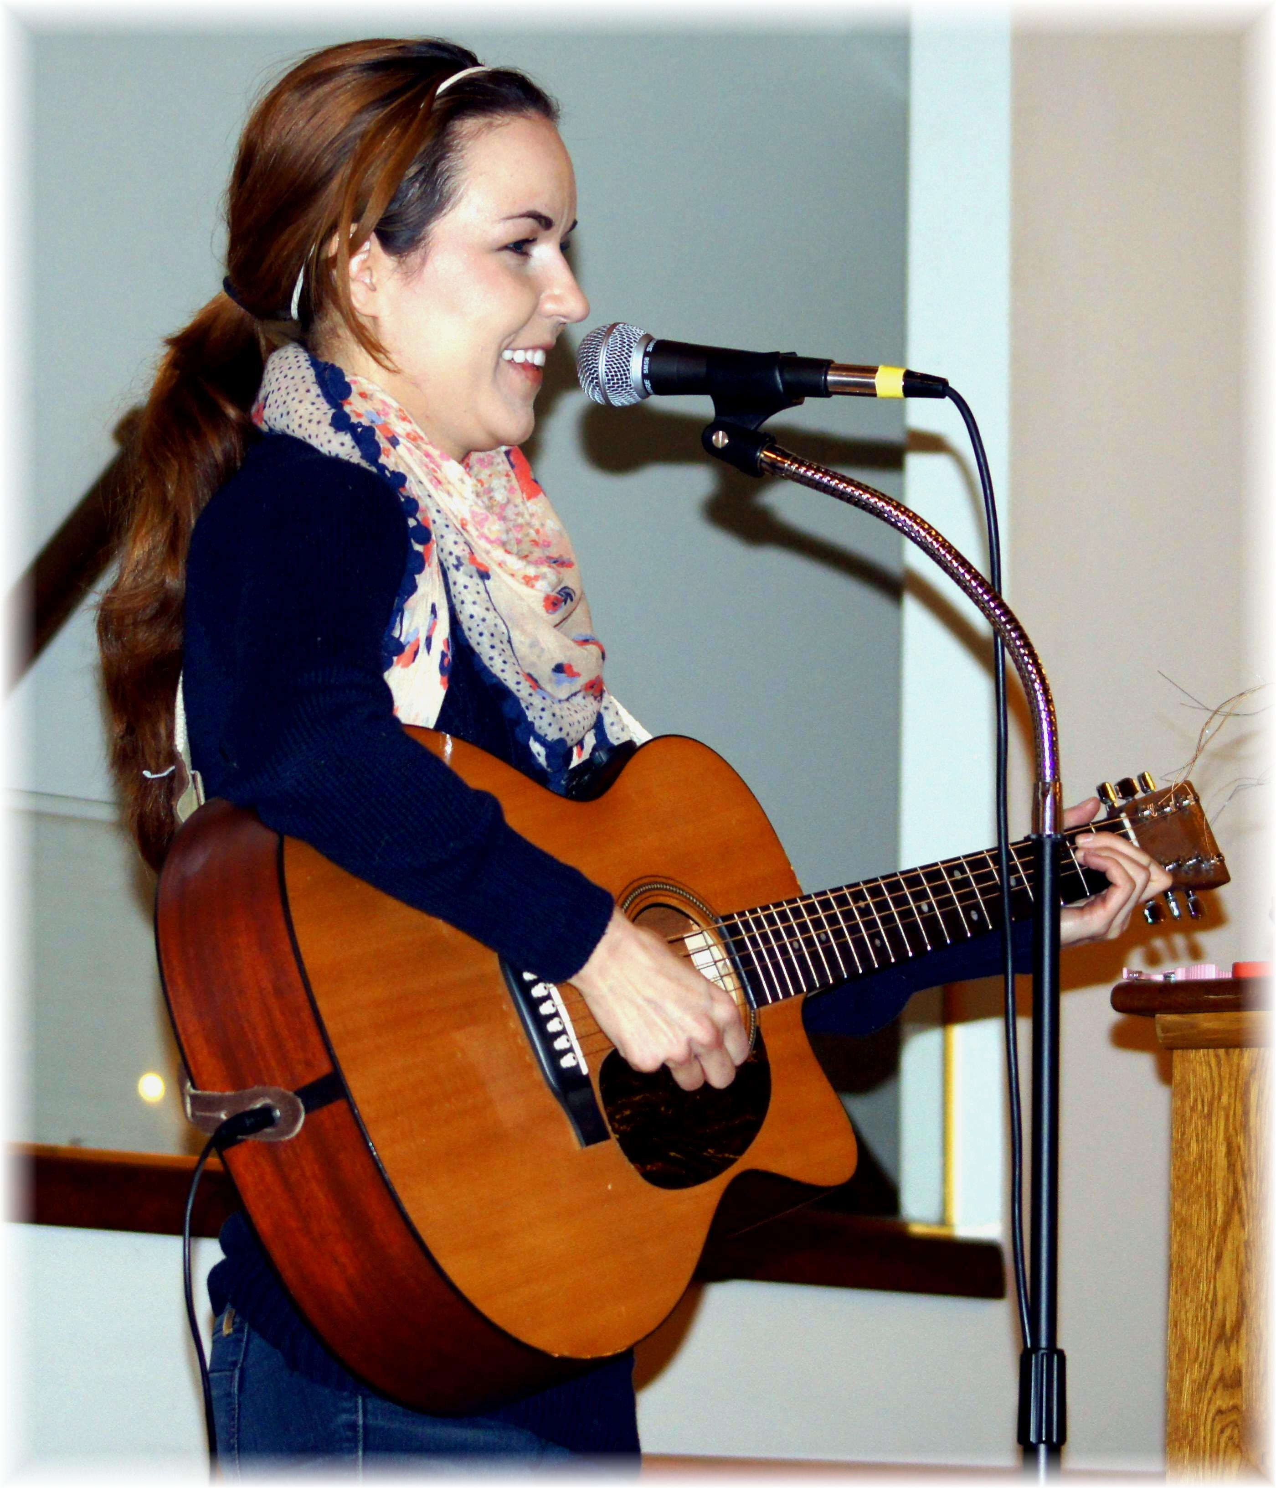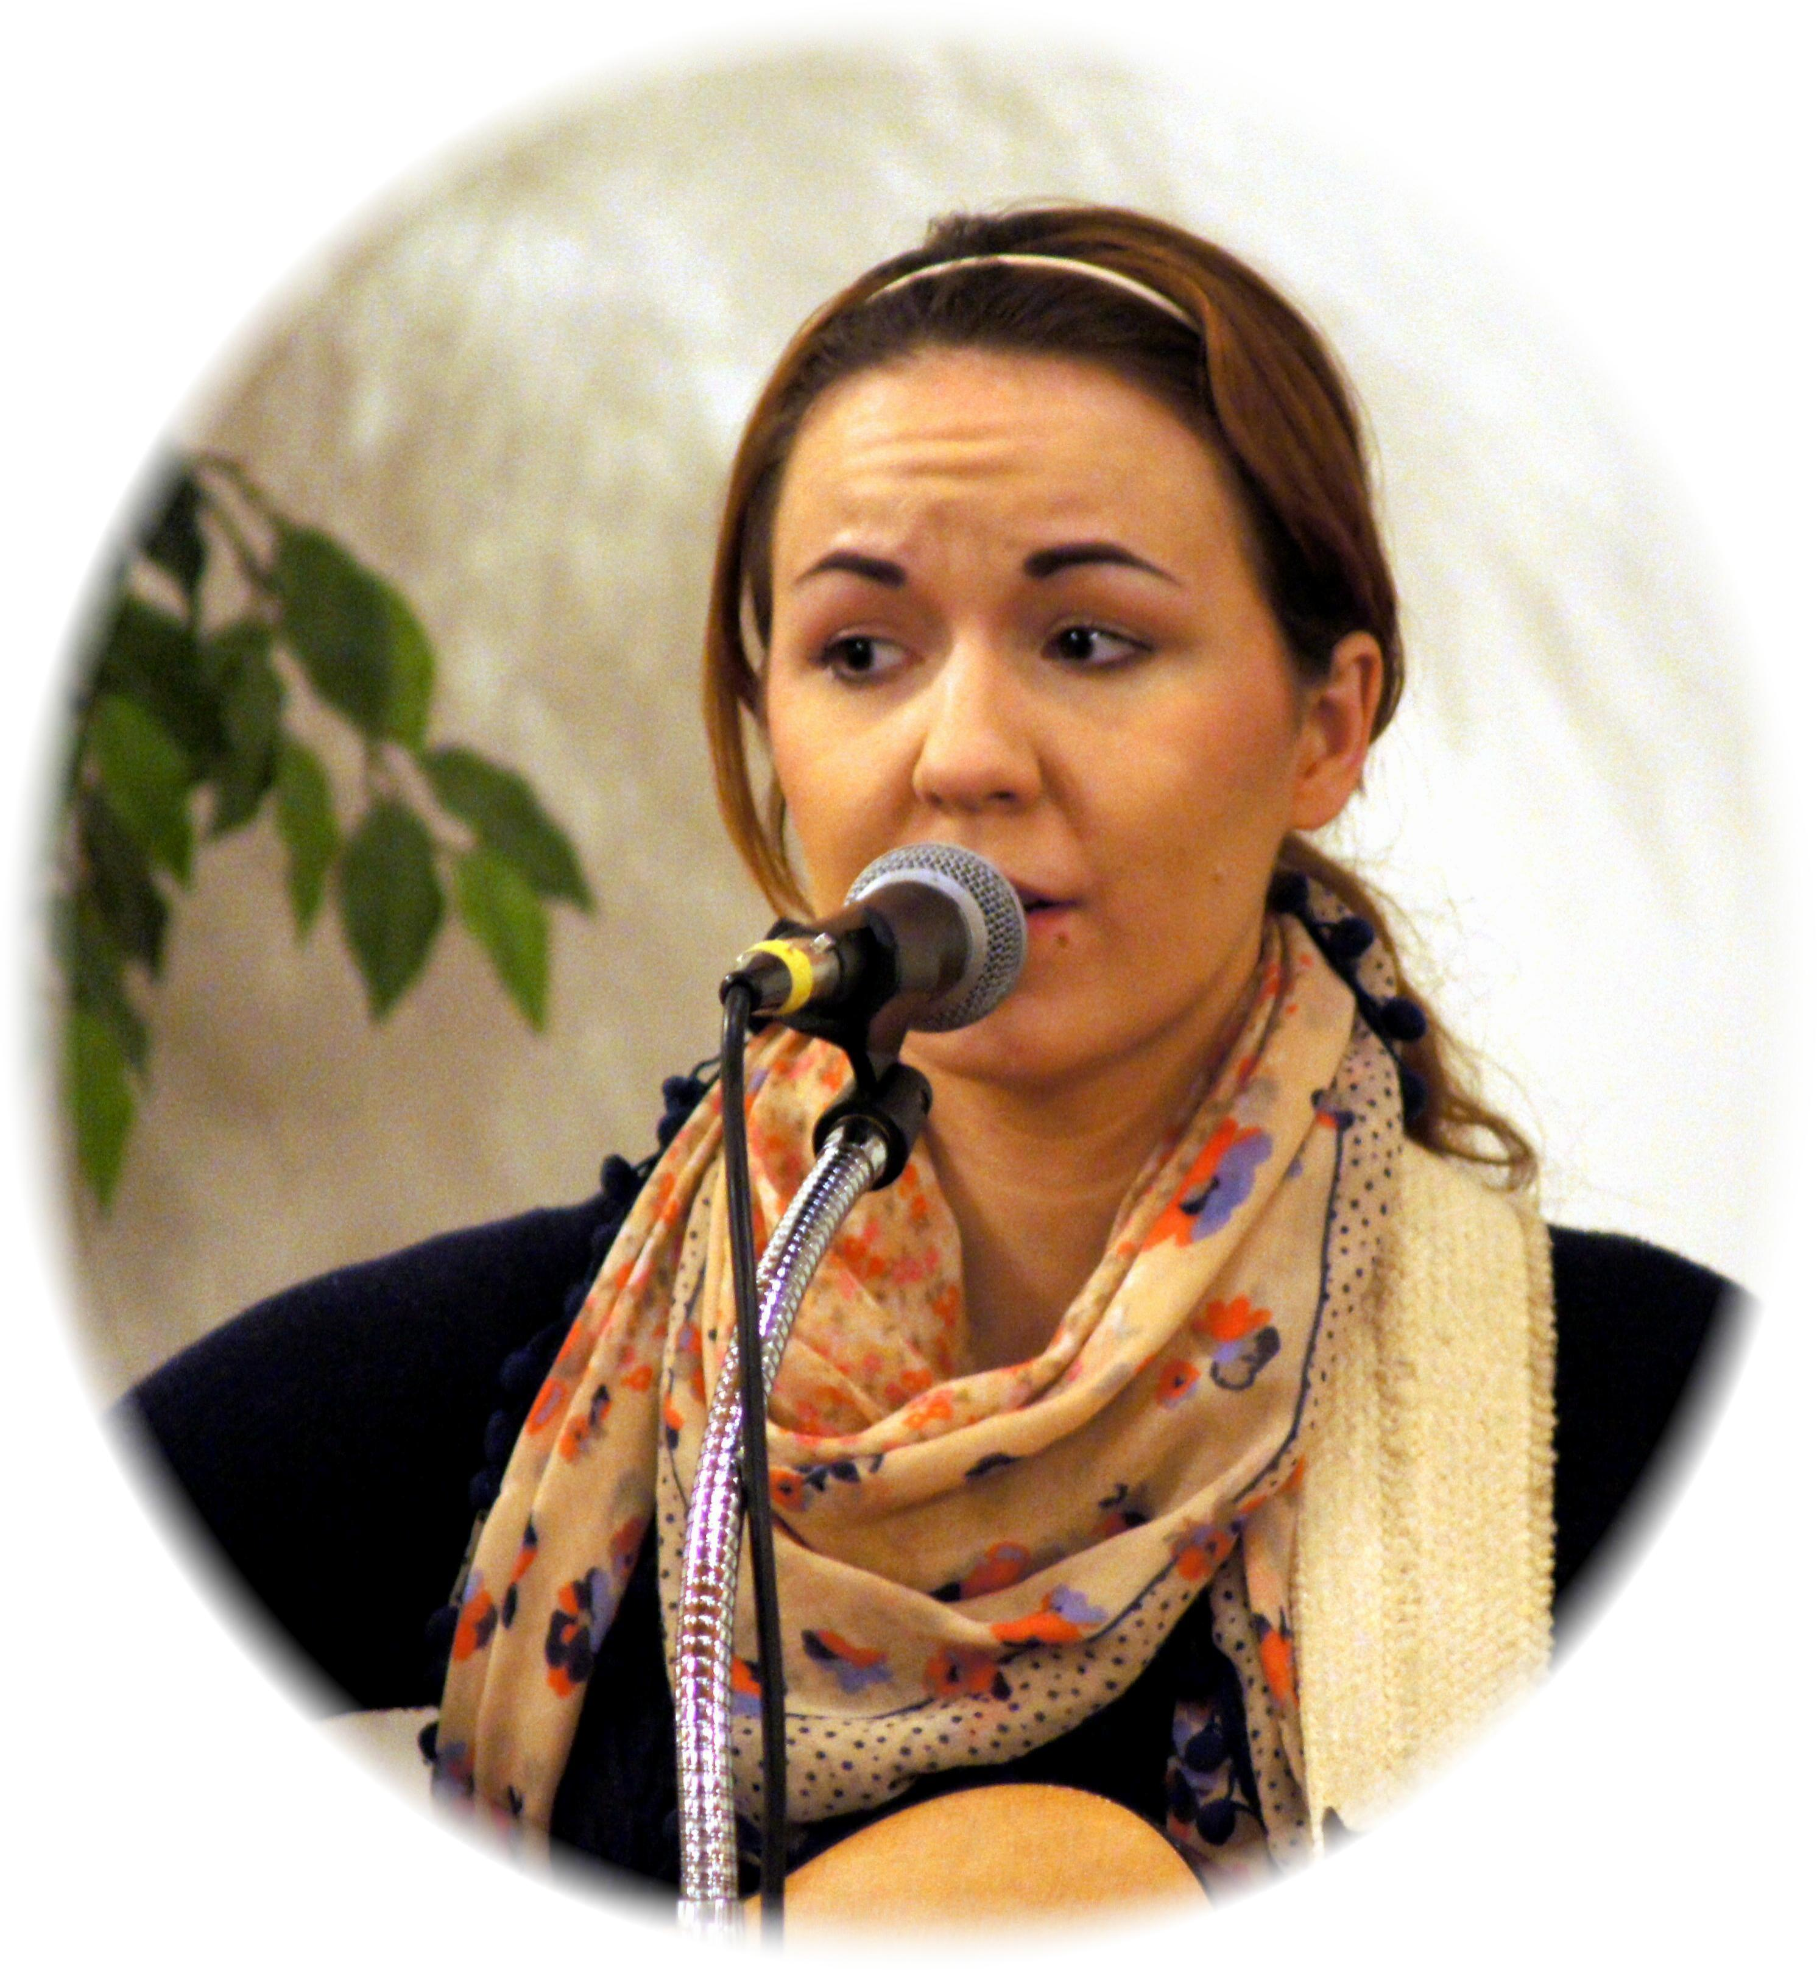
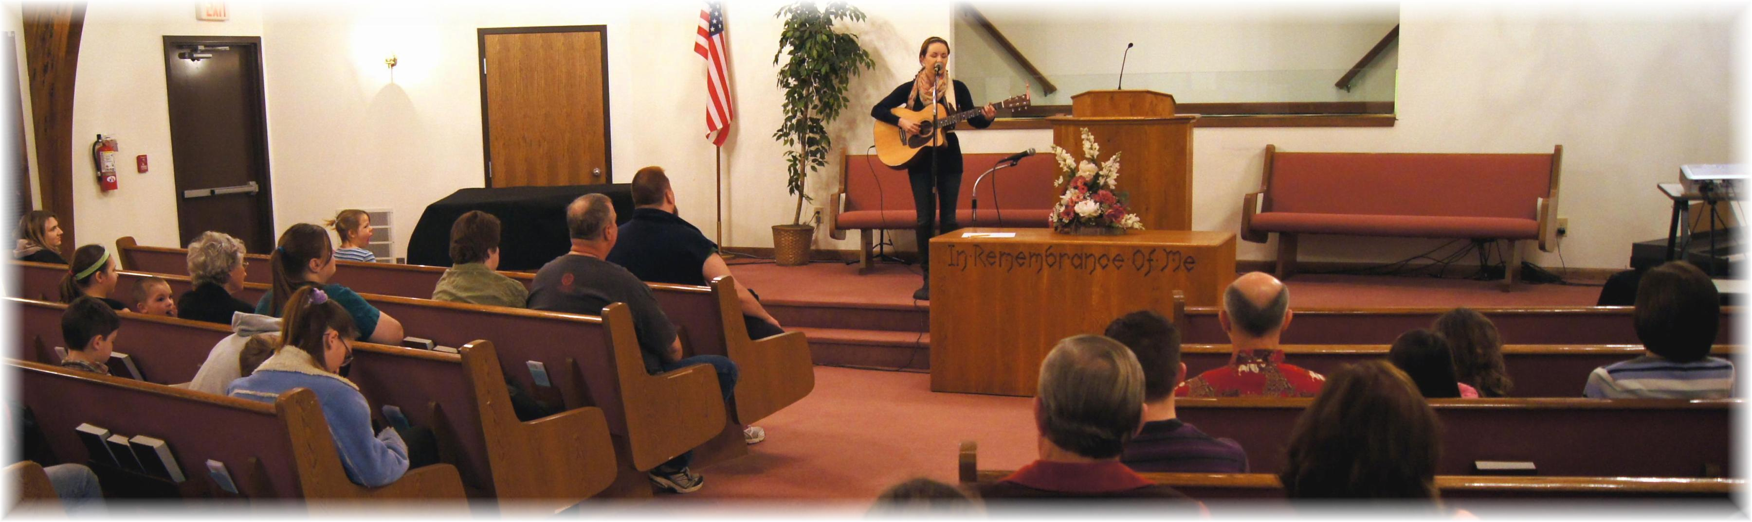

Alison Brook Concert – March 8, 2013

