Lancaster Seventh-Day Adventist Church
A House of Prayer for All People
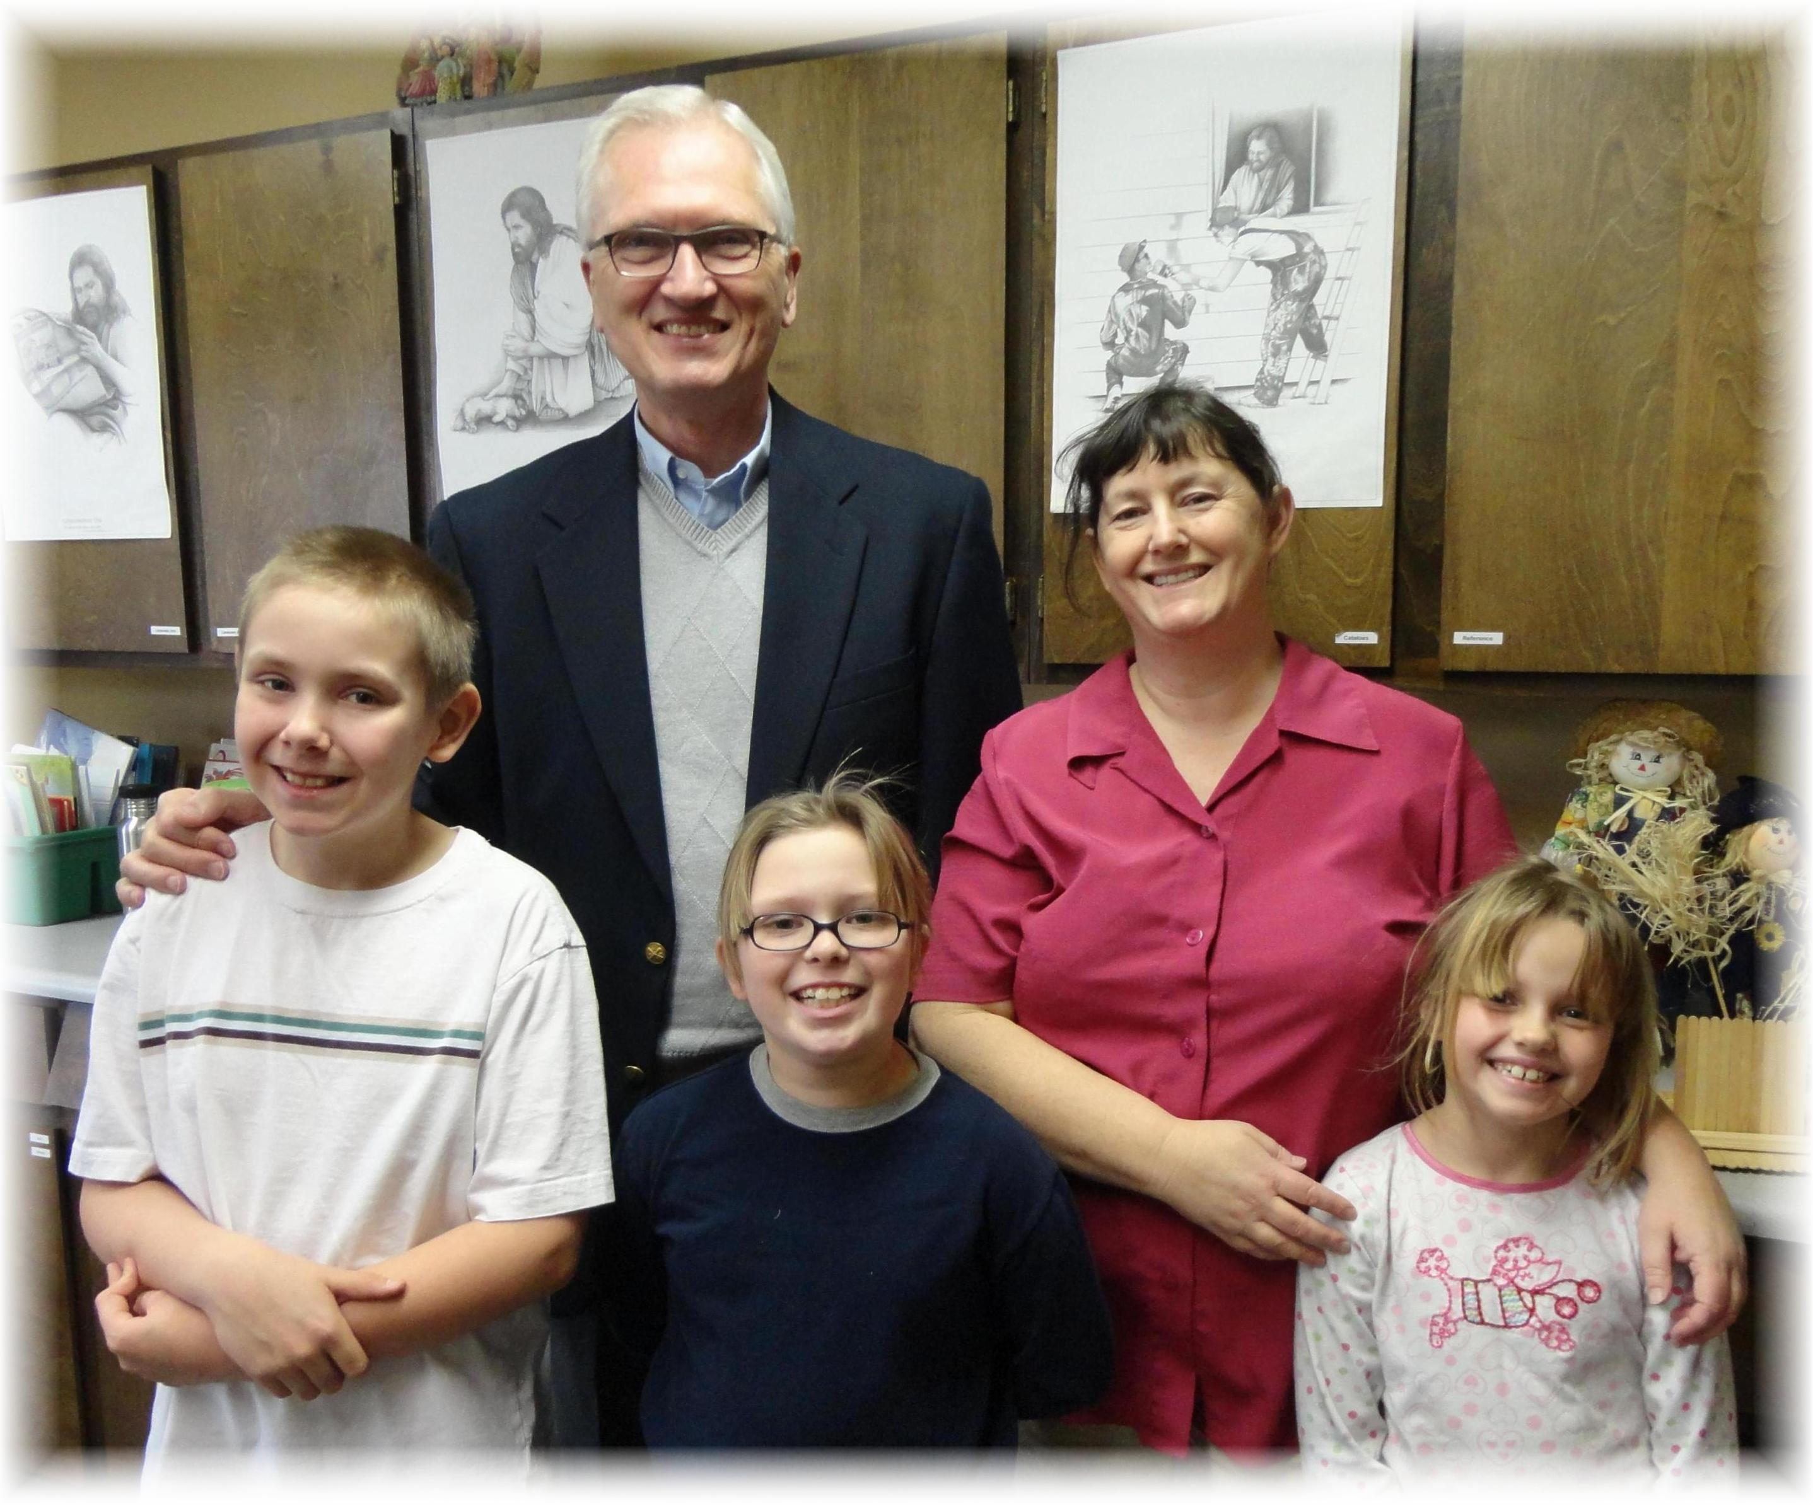
David, Jay Colburn, Asia, Kim Clarke, Sandra
School Visit – November 30, 2012

