Lancaster Seventh-Day Adventist Church
A House of Prayer for All People

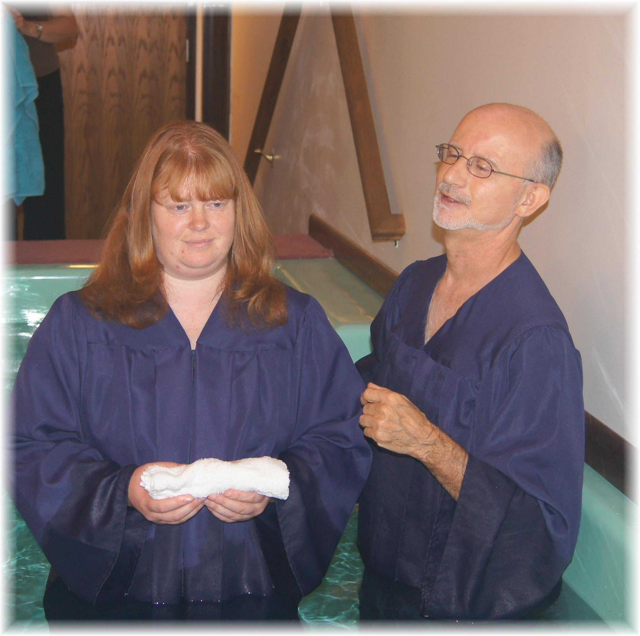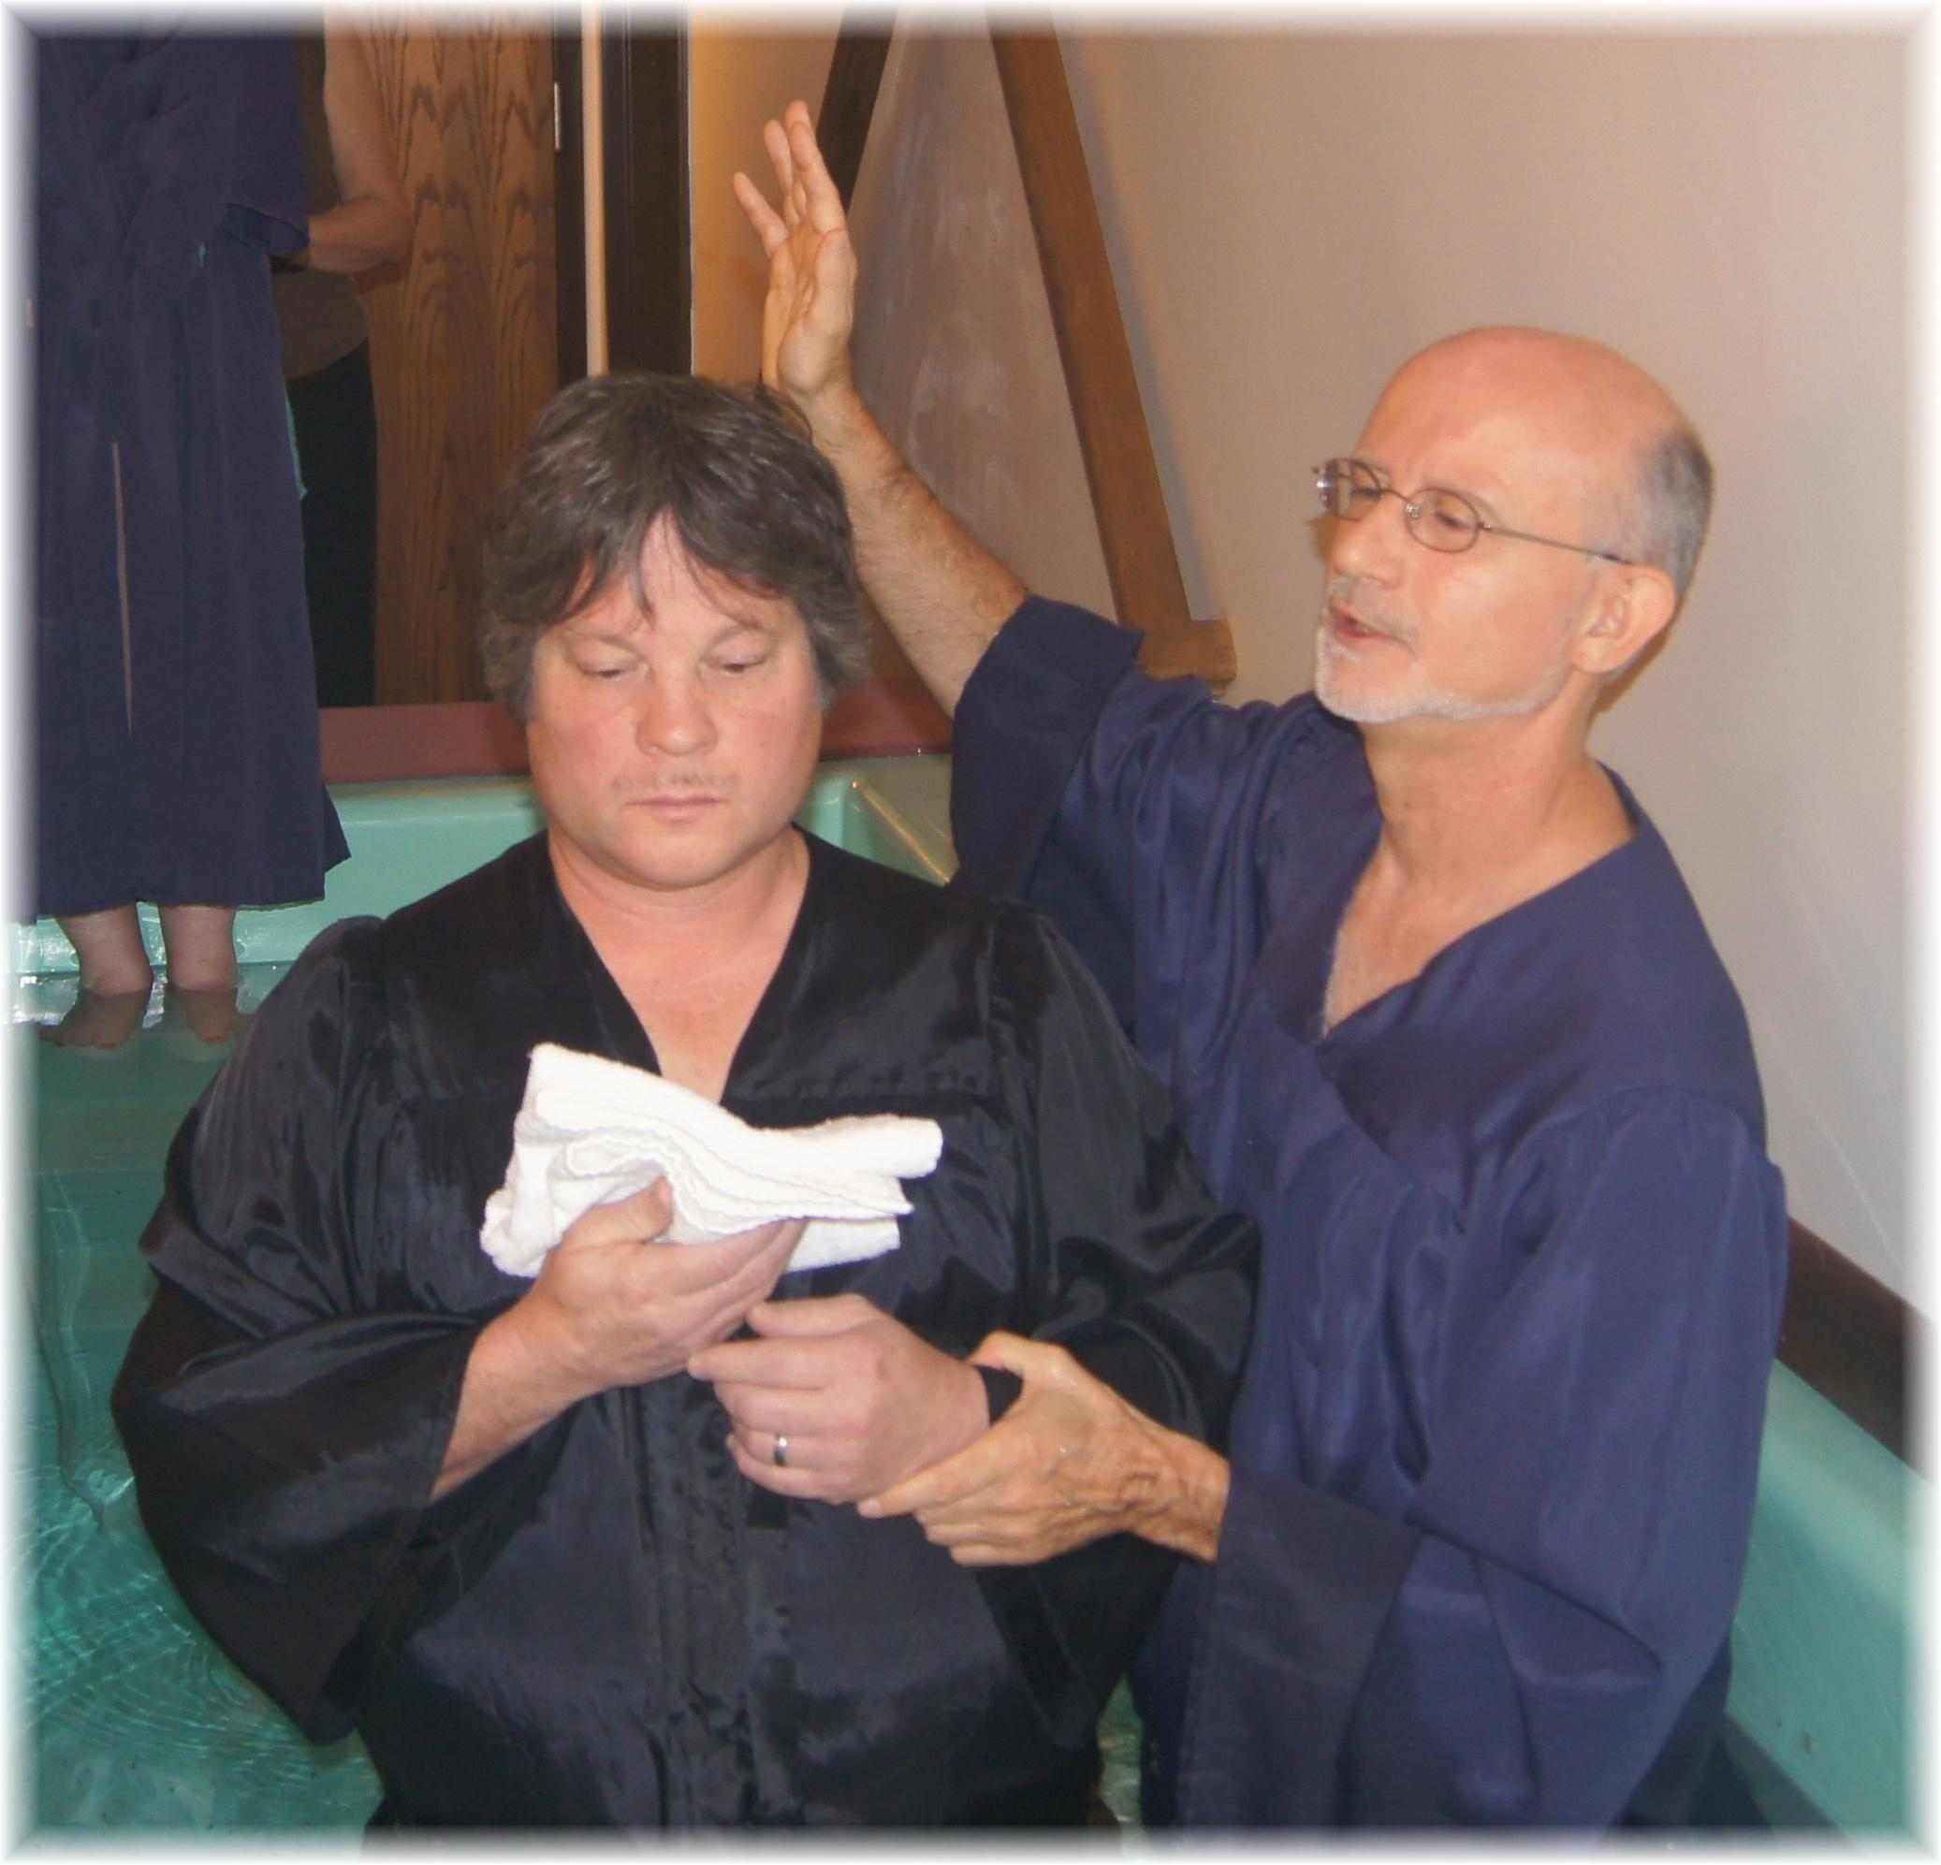

Baptisms of Tami and Jim Nichols – October 27, 2012

