Lancaster Seventh-Day Adventist Church
A House of Prayer for All People

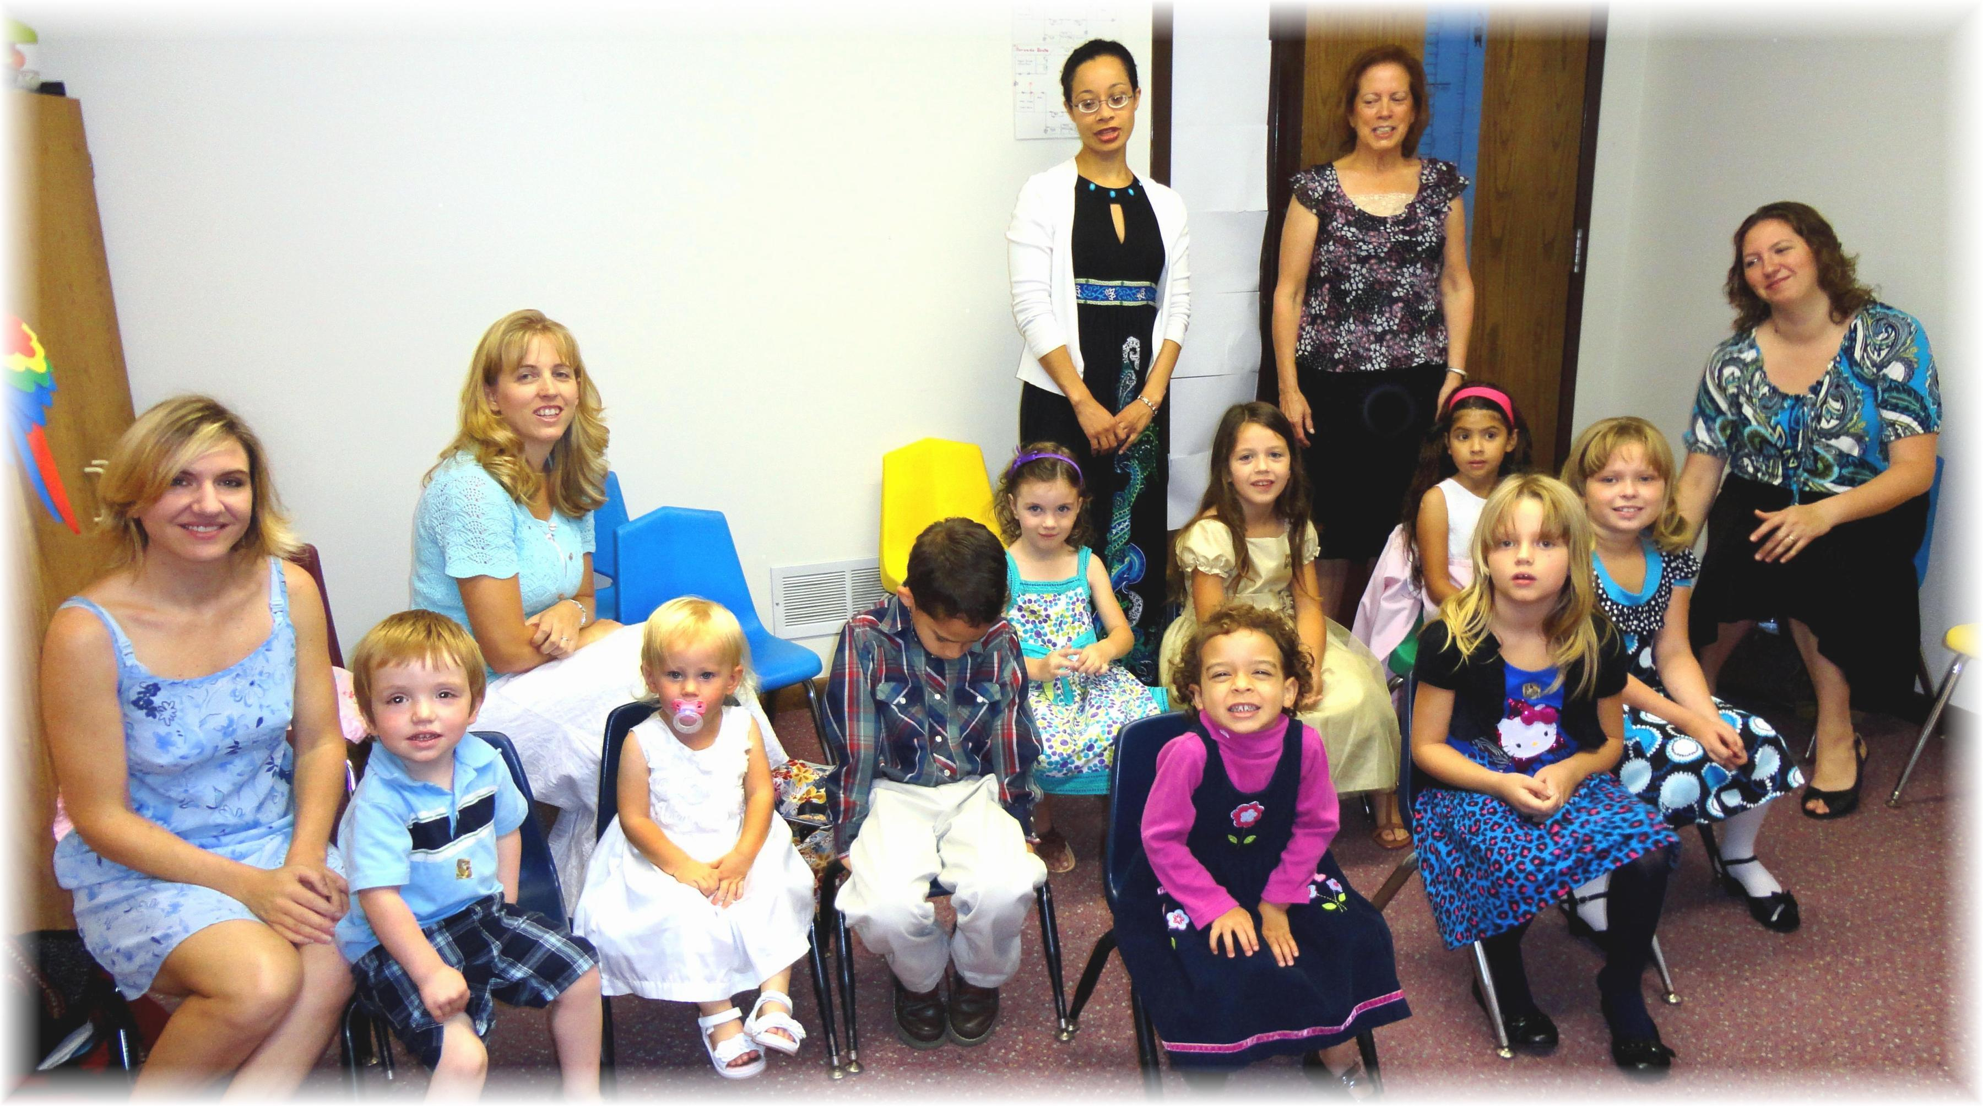
Children’s Sabbath School Class - 2012

