Lancaster Seventh-Day Adventist Church
A House of Prayer for All People

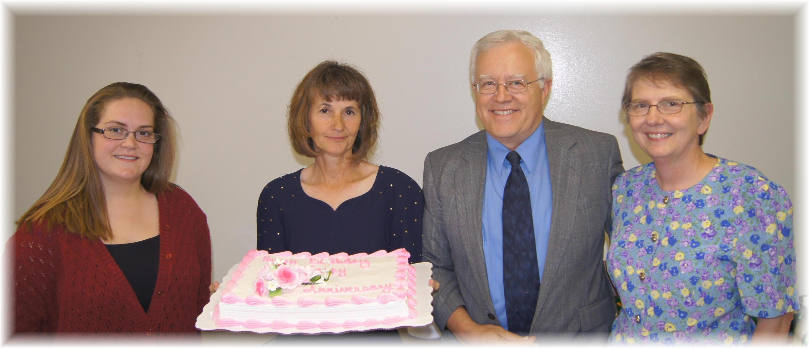
Birthdays: Jaydayle, Barb . Anniversary: Al and Bonnie
Birthdays and Anniversary – June, 2012

