Lancaster Seventh-Day Adventist Church
A House of Prayer for All People

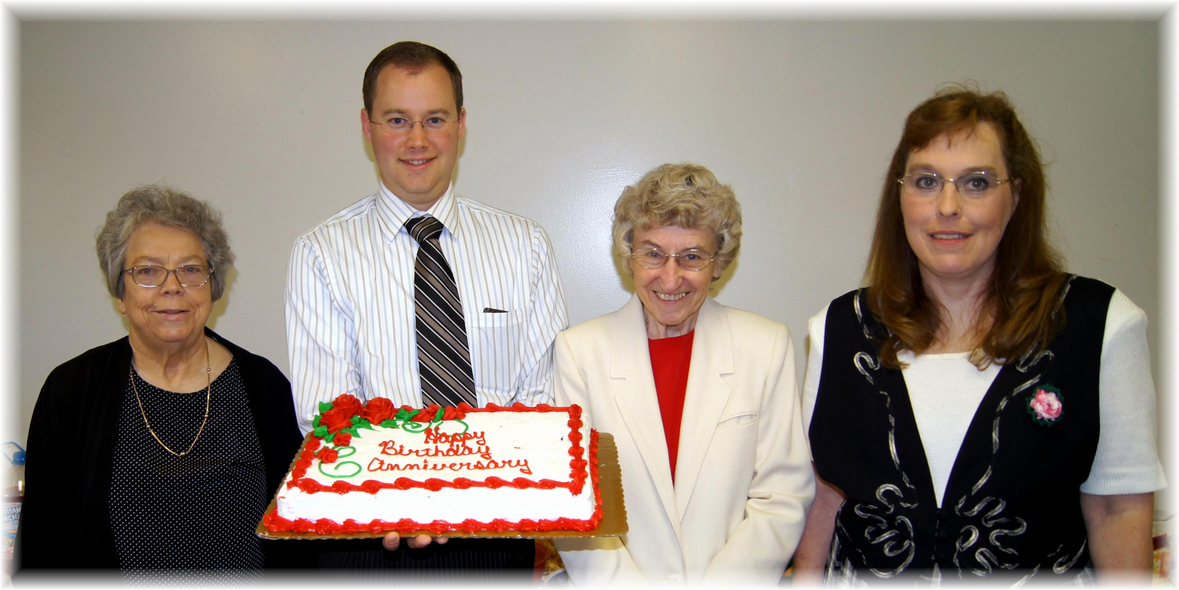
Birthdays: Josie, Joel, Freda Anniversary: Carol.
Birthdays and Anniversary – May, 2012

