Lancaster Seventh-Day Adventist Church
A House of Prayer for All People
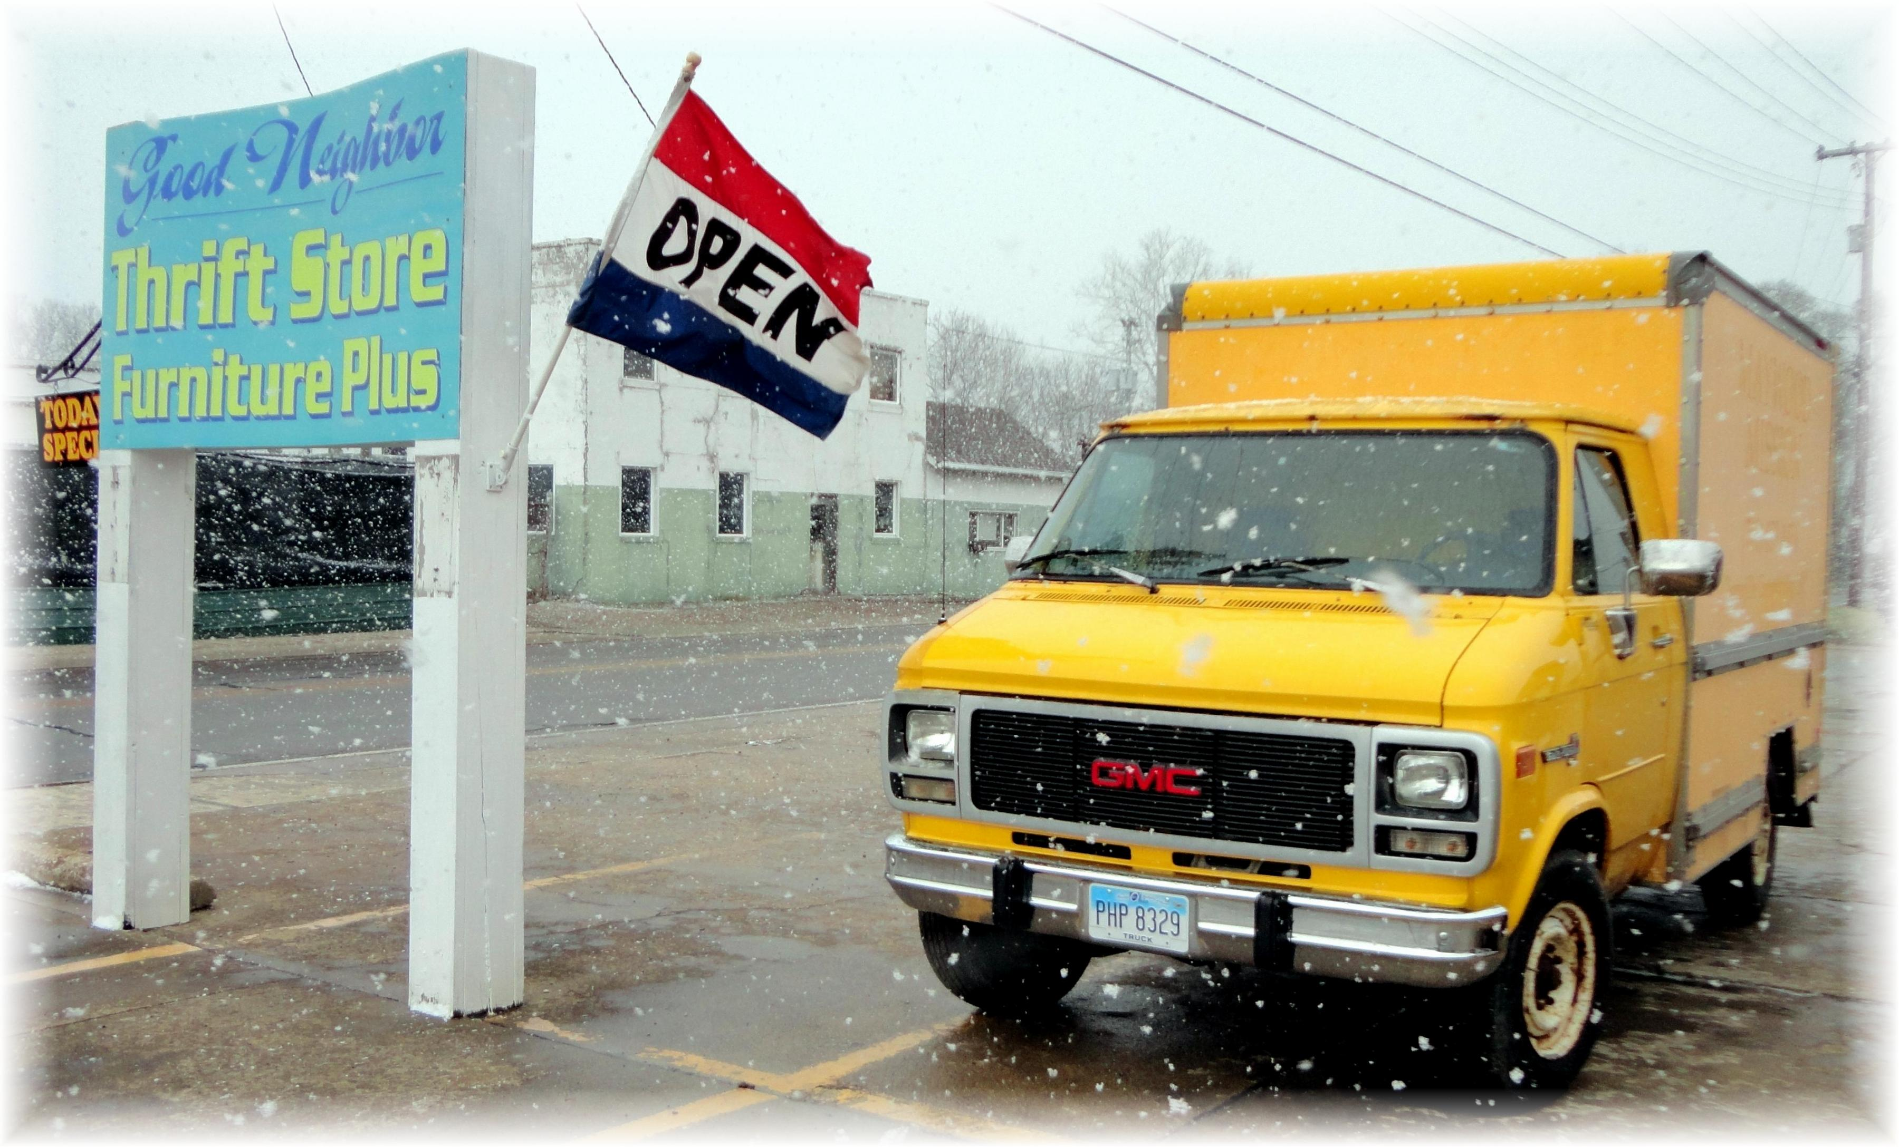
“Lemonade” ~ The Golden Blessing
The Good Neighbor Thrift Store Truck ~ February 15, 2012

