Lancaster Seventh-Day Adventist Church
A House of Prayer for All People

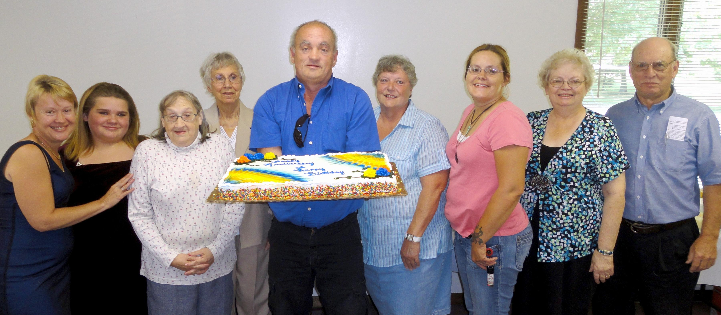

Birthdays: Deena, Brianna, Linda, Betty, Allen, Nadean, Lisa Anniversary: Sandy & Howard
August Birthdays and Anniversary - 2011

