Lancaster Seventh-Day Adventist Church
A House of Prayer for All People

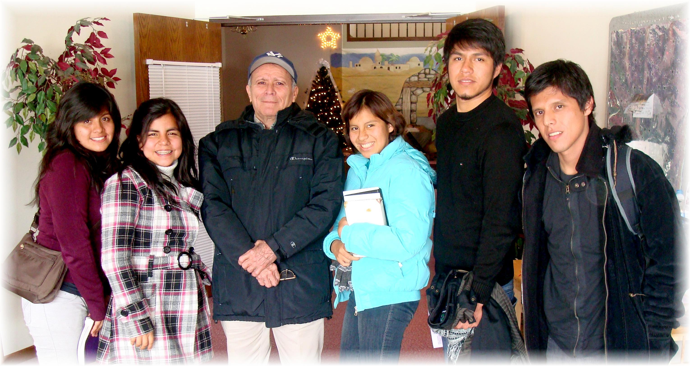
Our New Friends from Peru with Fidel - 2011

