Lancaster Seventh-Day Adventist Church
A House of Prayer for All People

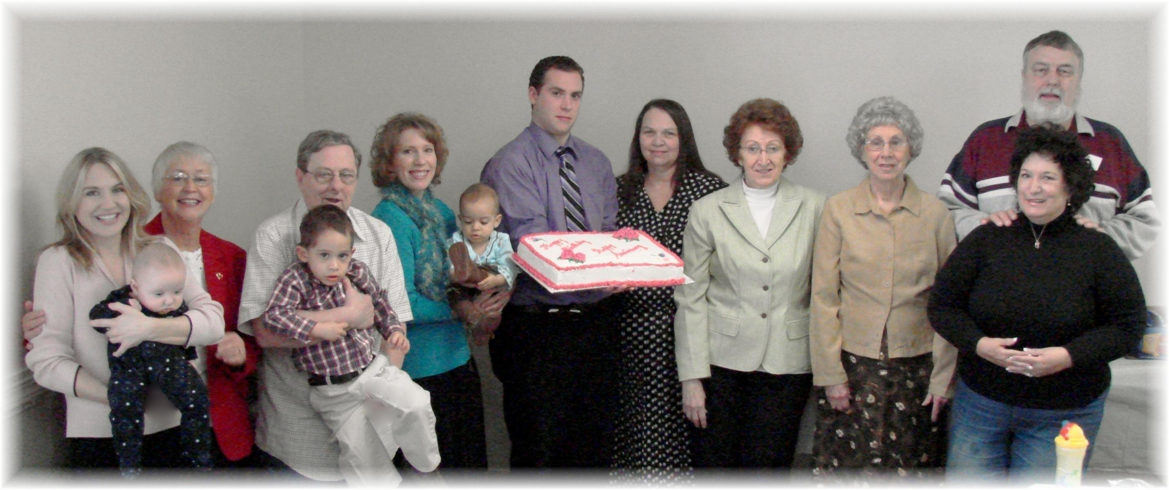
Birthdays: Trina (holding Jesse), Sharon, Elijah, David, Cheryl, Abigail, Alan, Debby, Alice
Anniversaries: Betty, Kay & Mike
February Birthdays and Anniversaries - 2010

