Lancaster Seventh-Day Adventist Church
A House of Prayer for All People

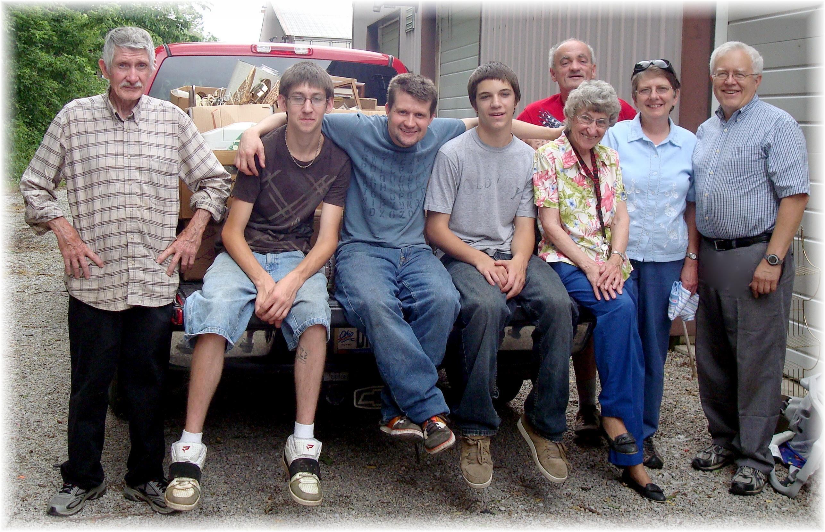
George, Travis, Allen, Randall, Allen, Freda, Bonnie, Al
Good Neighbor Thrift Store Yard Sale Crew – June 13, 2010

