Lancaster Seventh-Day Adventist Church
A House of Prayer for All People

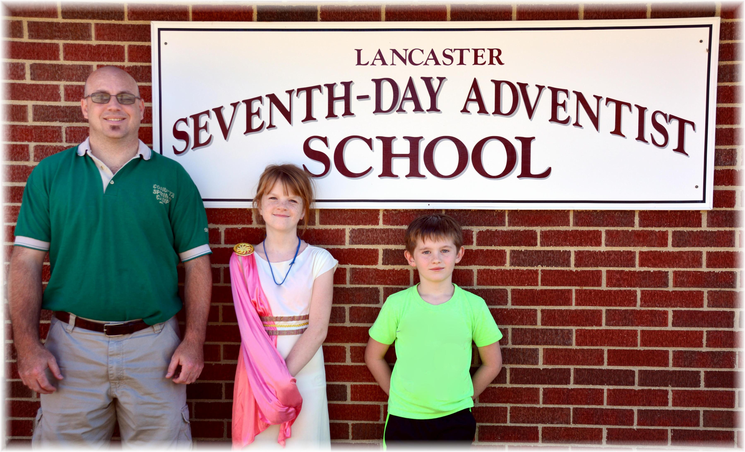
Lancaster SDA Online School ~~ November 2015

