Lancaster Seventh-Day Adventist Church
A House of Prayer for All People

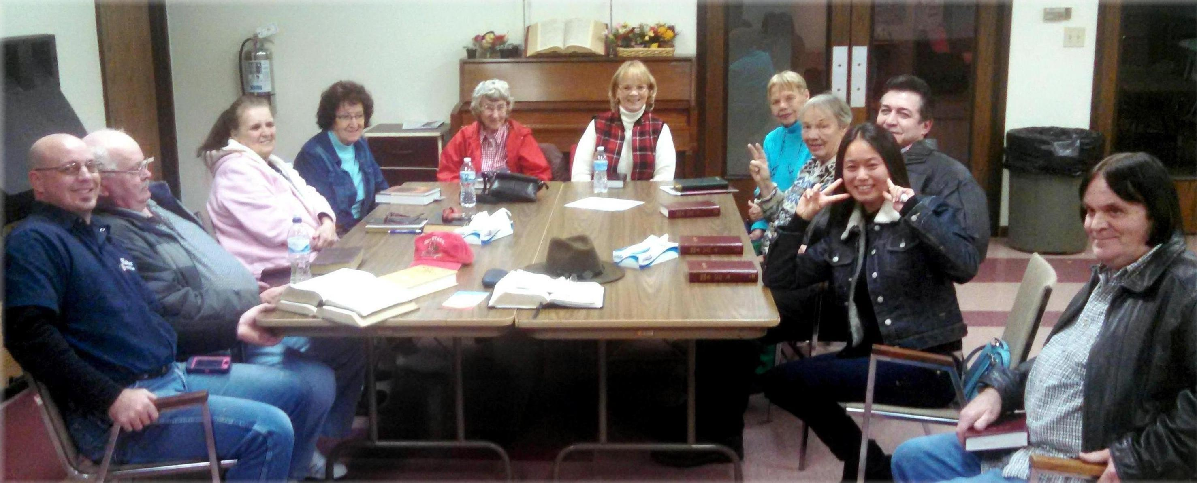
Prayer Meeting – November 2014

