Lancaster Seventh-Day Adventist Church
A House of Prayer for All People

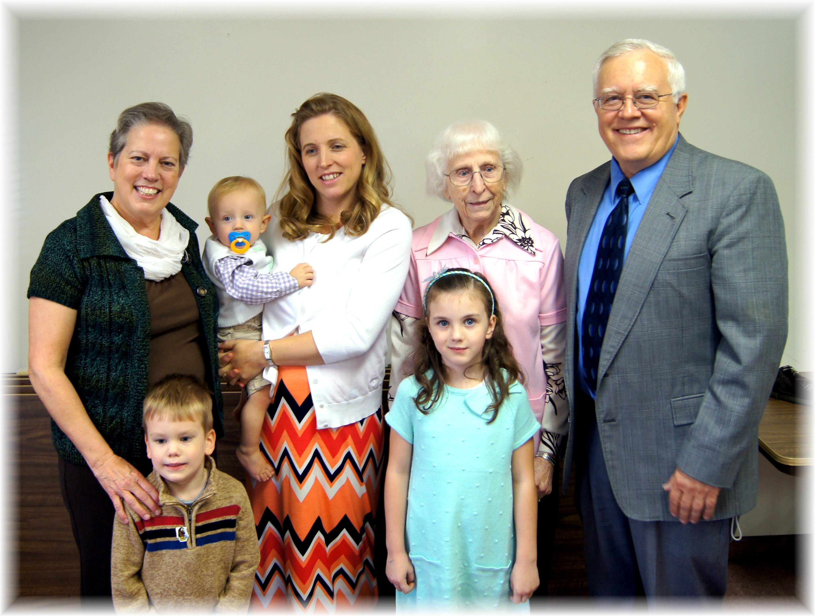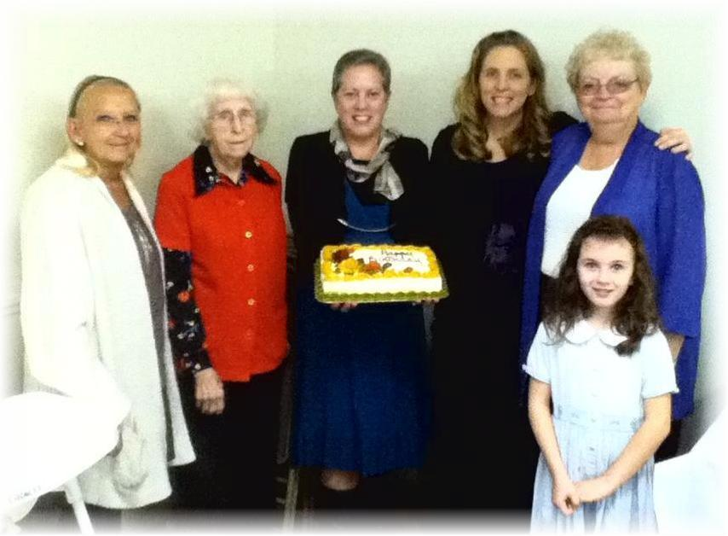
Picture 1: Geri, Aiden, Marijke (holding Nathan), Alena, Edith, Al
Picture 2: Christy, Edith, Geri, Marijke, Sandy, Alena (front)
October Birthdays - 2014

