Lancaster Seventh-Day Adventist Church
A House of Prayer for All People

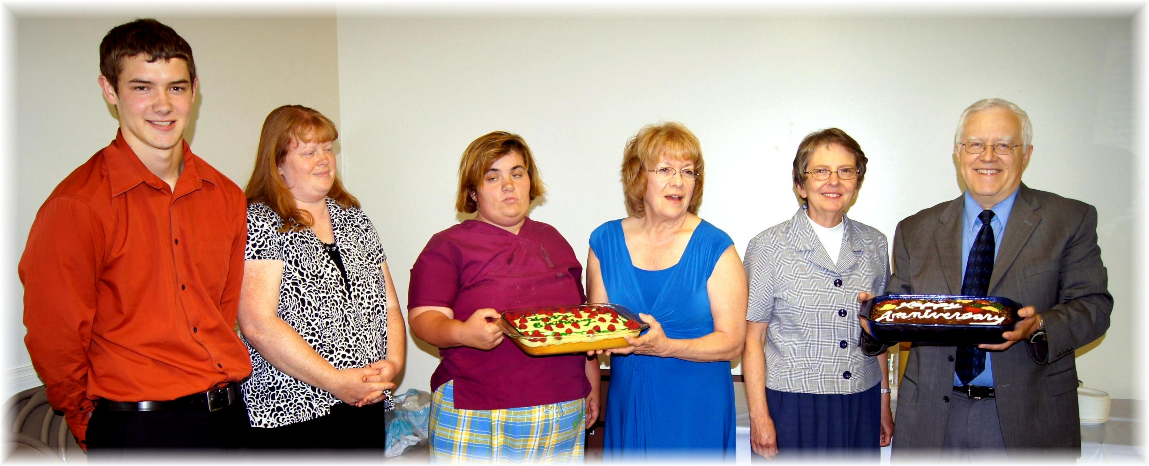
Birthdays: Jay, Tami, Jessie, Donna . Anniversary: Bonnie & Al
Birthdays and Anniversary – June, 2014

