Lancaster Seventh-Day Adventist Church
A House of Prayer for All People

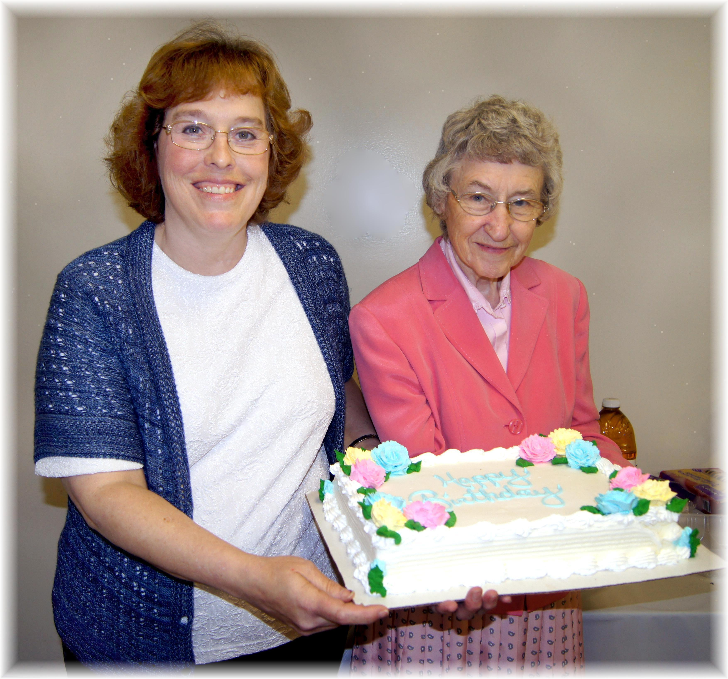
Anniversary: Carol Birthday: Freda
Anniversary and Birthday – May, 2014

