Lancaster Seventh-Day Adventist Church
A House of Prayer for All People

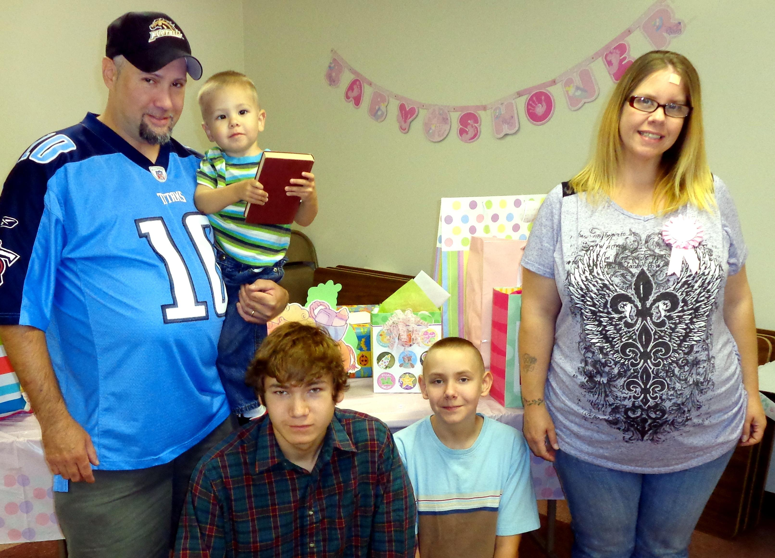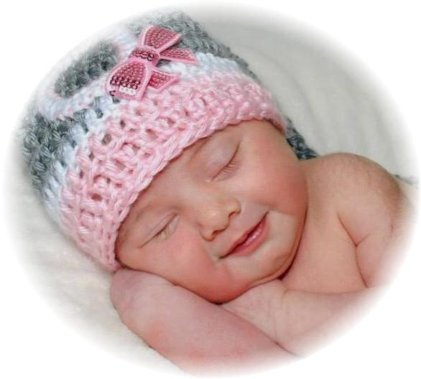

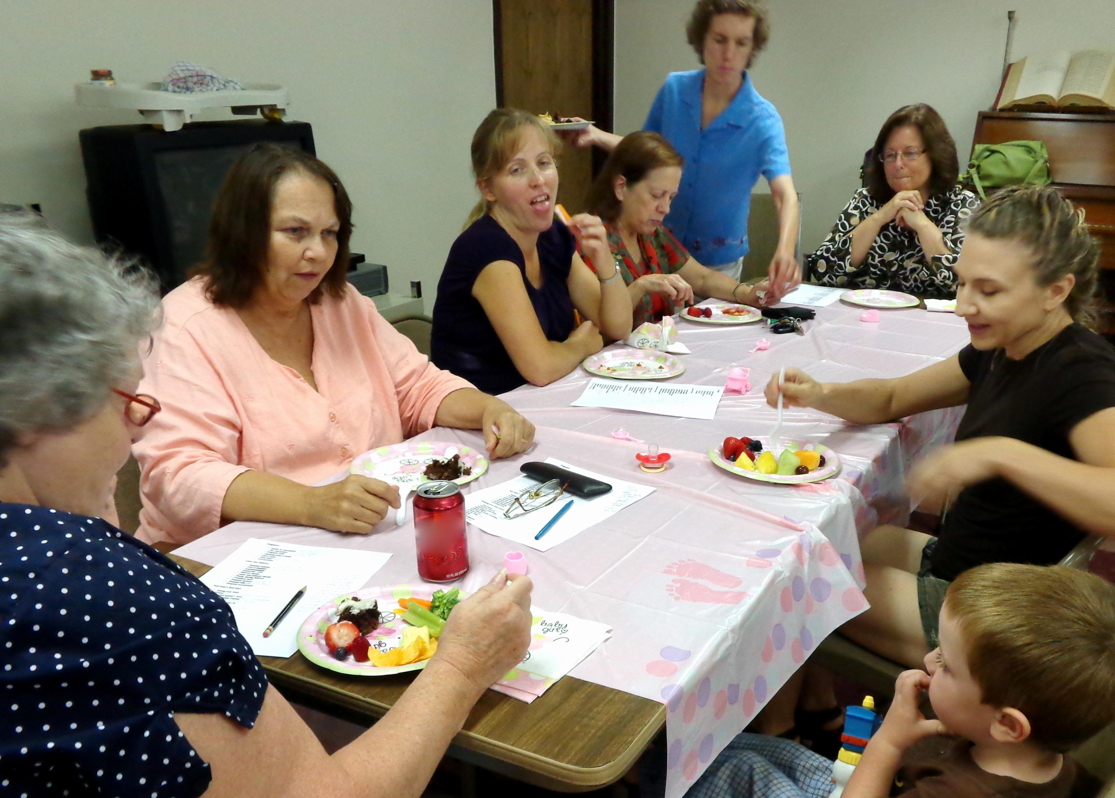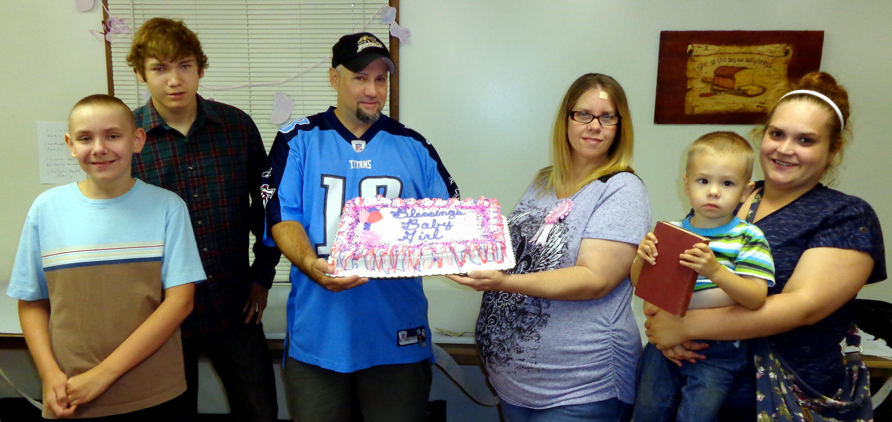

Andrea & Rob Baby Shower – August 21, 2013
Liv Snyder, born September 9, 2013

