Lancaster Seventh-Day Adventist Church
A House of Prayer for All People

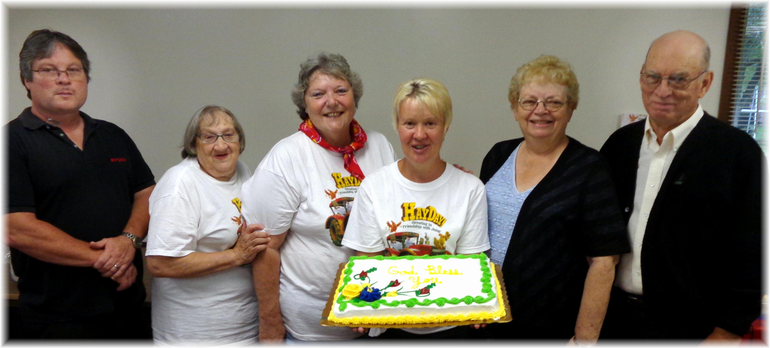

Birthdays: Jim, Linda, Nadean, Deena Anniversary: Sandy & Howard
August Birthdays and Anniversary - 2013

