Lancaster Seventh-Day Adventist Church
A House of Prayer for All People

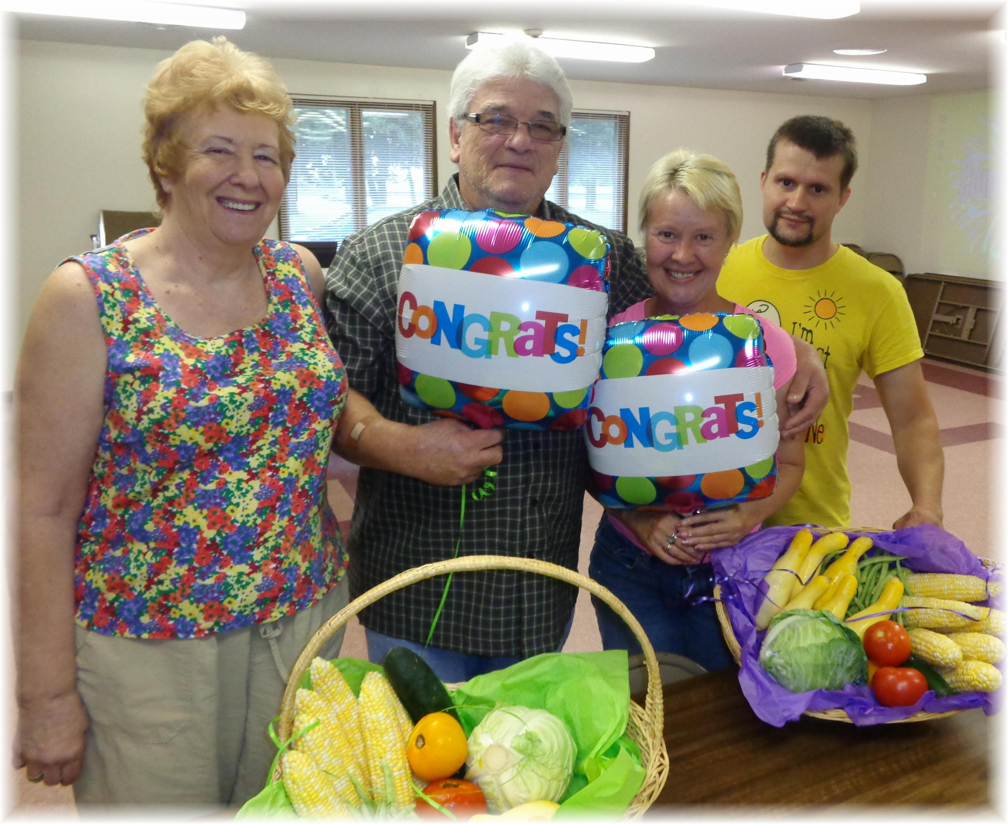
Diane, John, Deena, Allen
Breath Free Class Graduation - July 23, 2013

