Lancaster Seventh-Day Adventist Church
A House of Prayer for All People

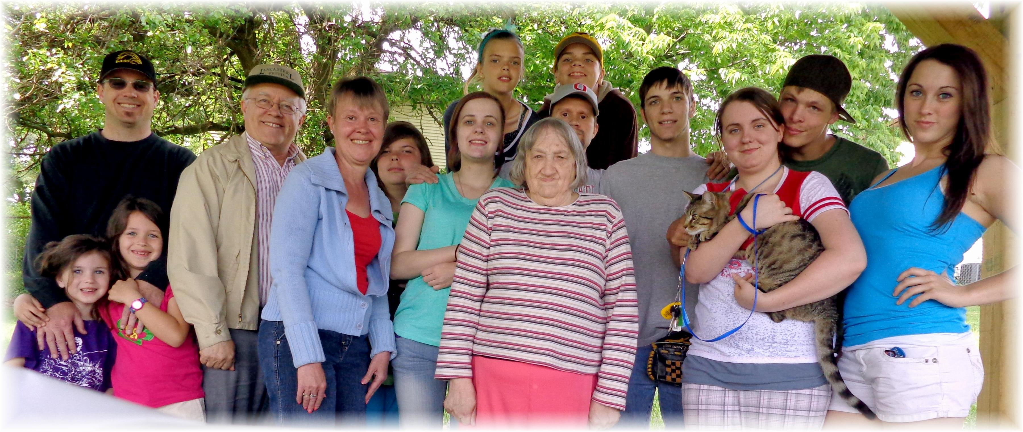
Health Team Picnic Baseball Social – May 26, 2013

