Lancaster Seventh-Day Adventist Church
A House of Prayer for All People

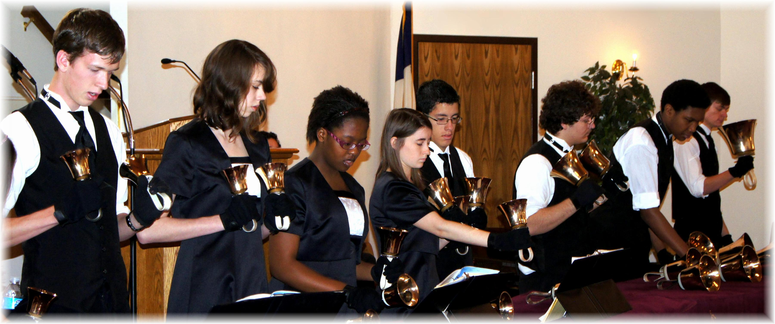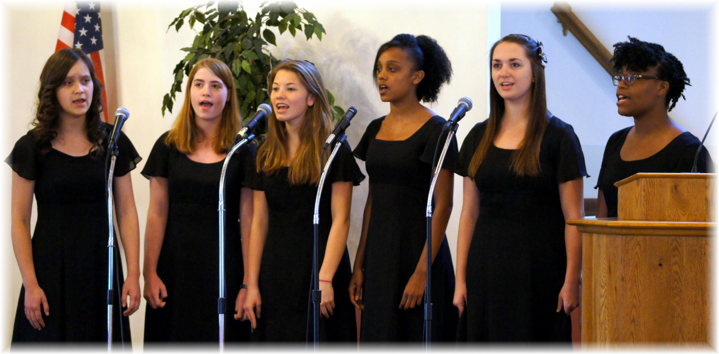

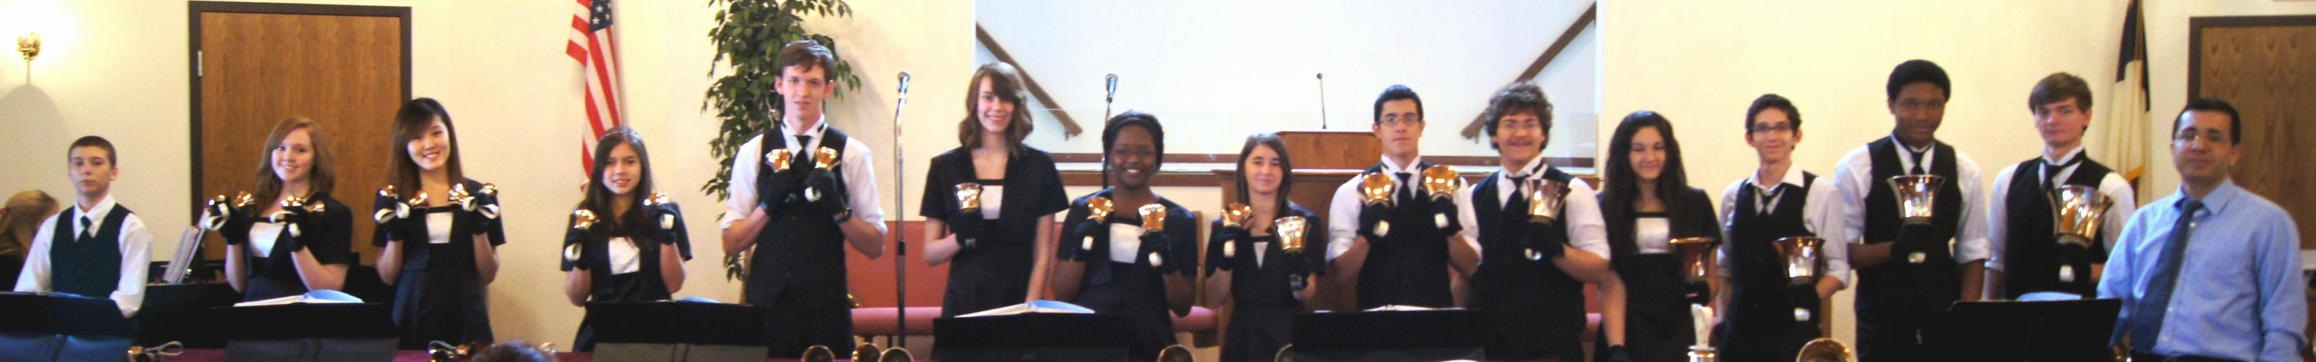

Mt. Vernon Academy Echoliers & Cascabel Handbell Ensemble
February 16, 2013

