Lancaster Seventh-Day Adventist Church
A House of Prayer for All People

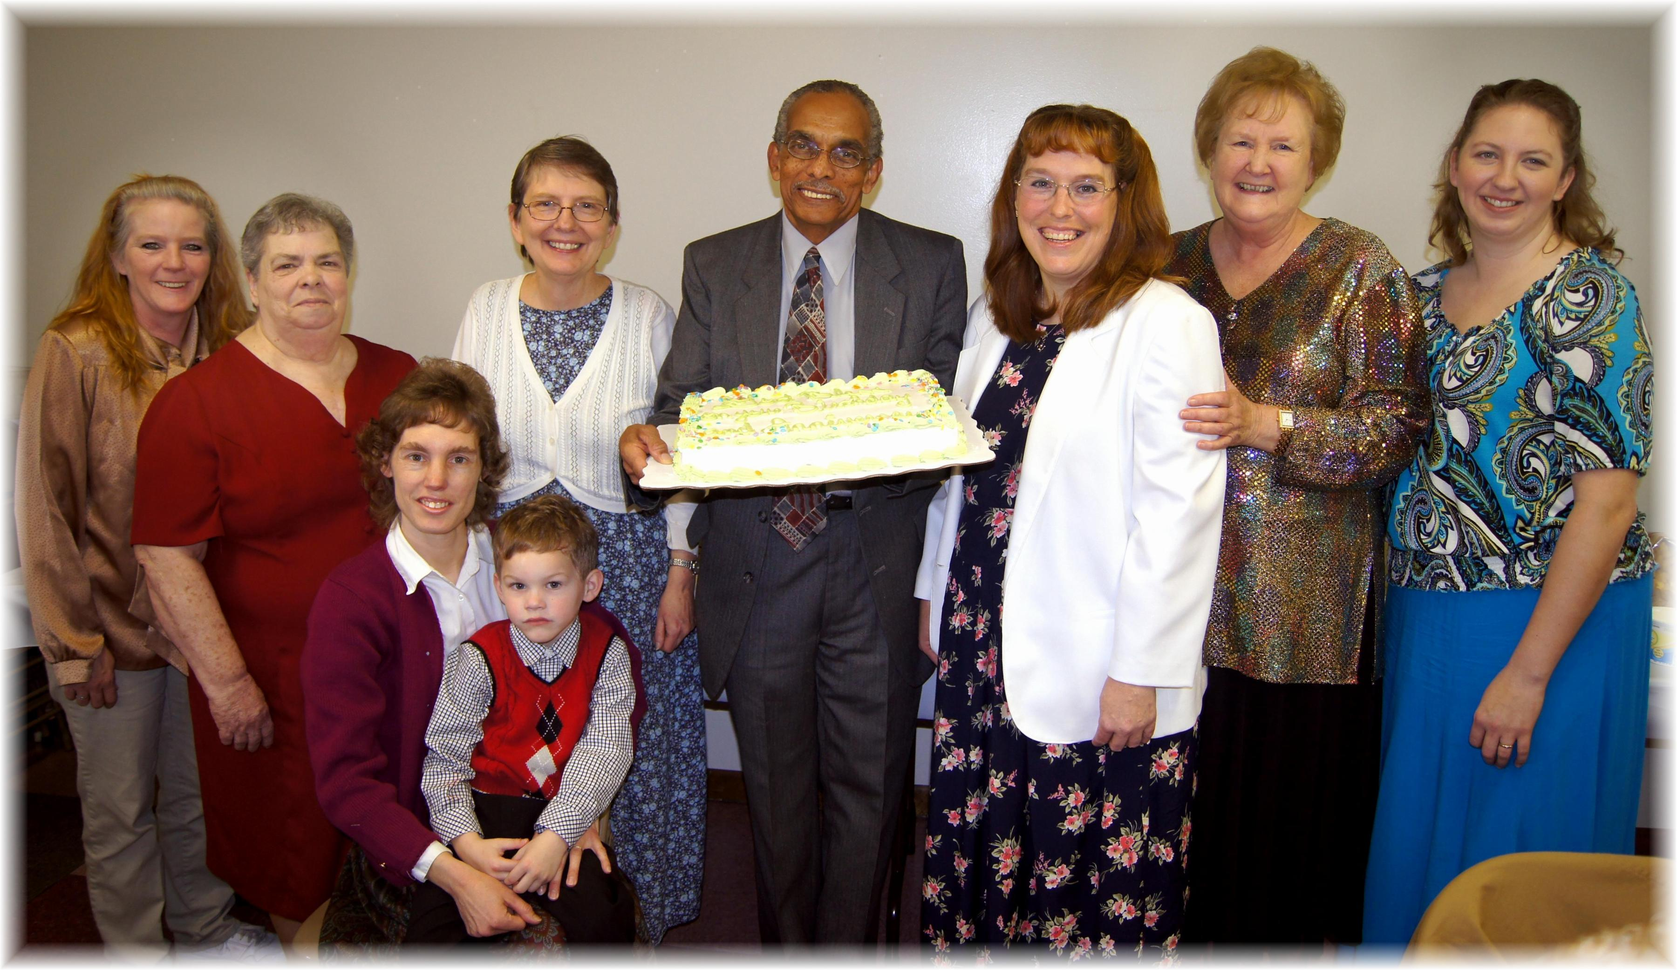
Lorie, Evelyn, Andrew (held by Connie), Bonnie, Rick, Carol, Linda, Jennifer
January Birthdays - 2013

