Lancaster Seventh-Day Adventist Church
A House of Prayer for All People

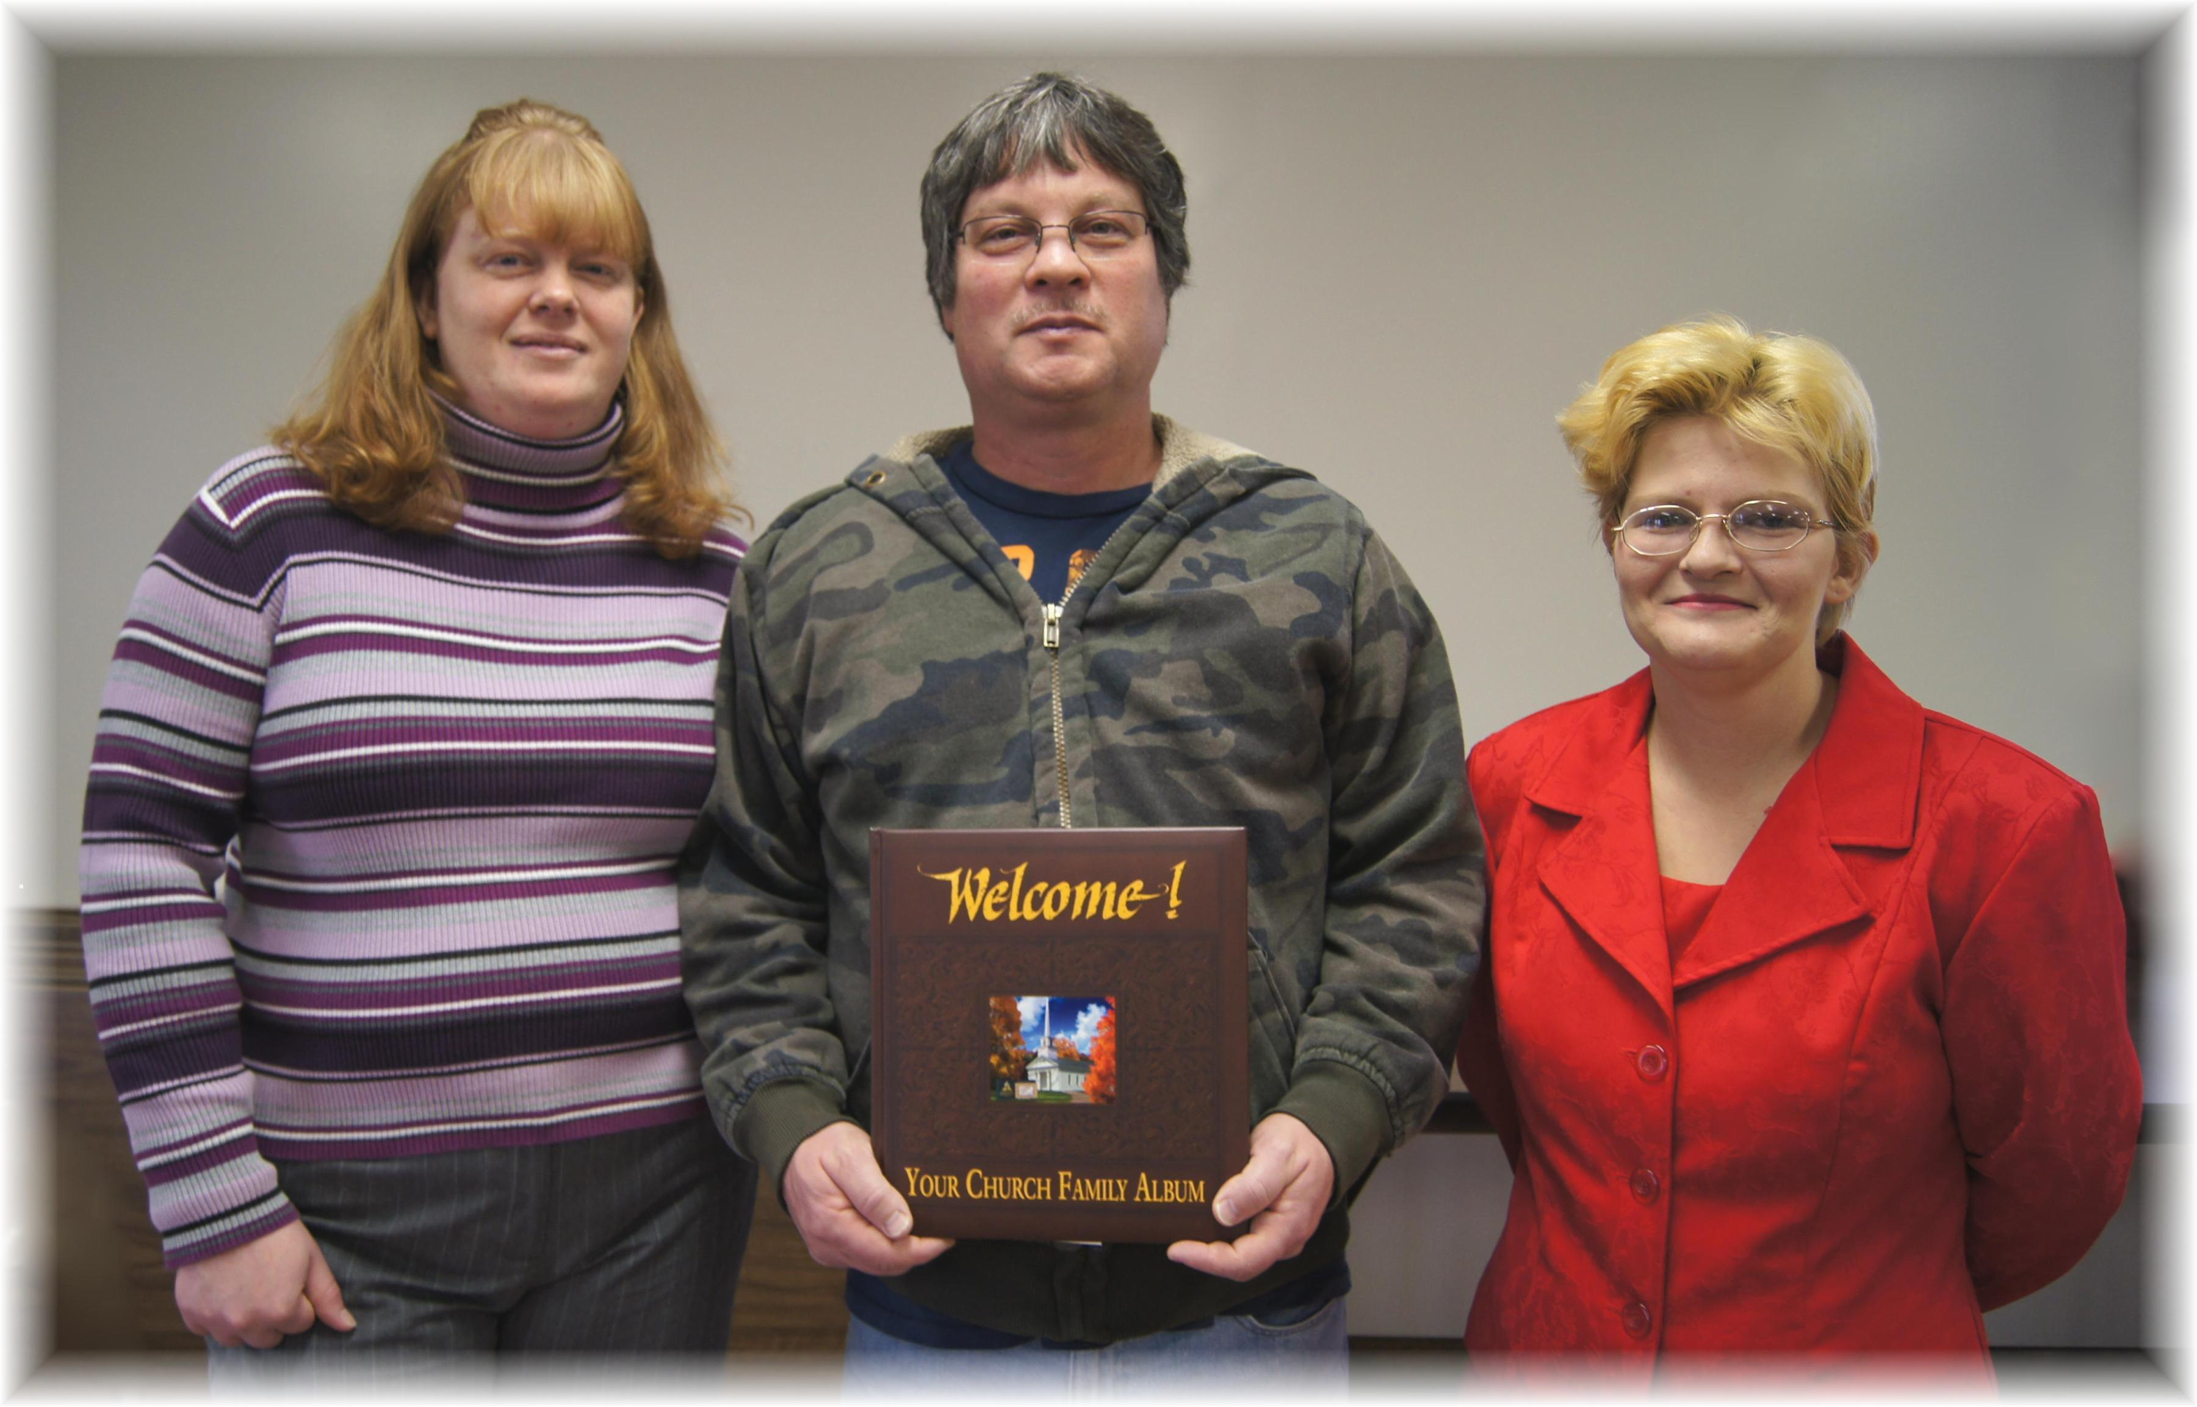
Tami & Jim Nichols, Amy Riley
Our Newest Members – October & November, 2012

