Lancaster Seventh-Day Adventist Church
A House of Prayer for All People
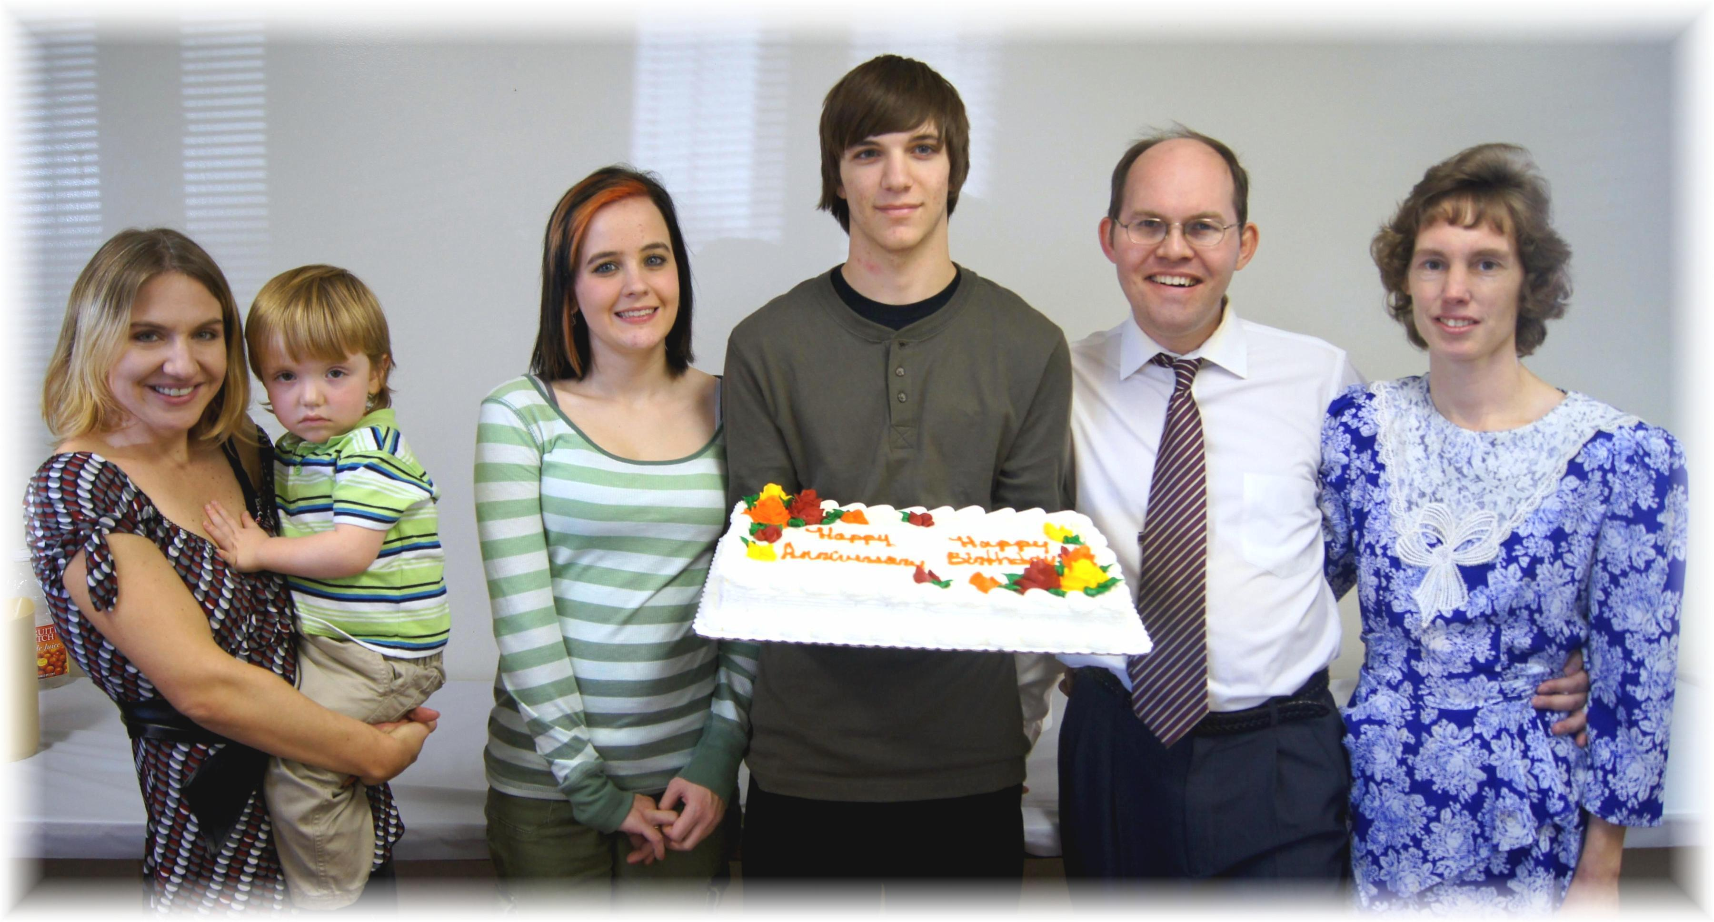
Birthday: Jesse (with Trina) Anniversaries: Charity & Randall, James & Connie
November Birthday and Anniversaries - 2012

