Lancaster Seventh-Day Adventist Church
A House of Prayer for All People
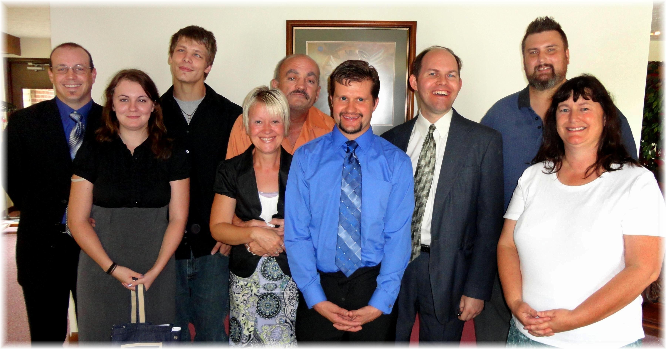

Anthony, Shaina, Seth, Deena, Allen, Allen, James, Willie, Kim
Skittles - September, 2012

