Lancaster Seventh-Day Adventist Church
A House of Prayer for All People

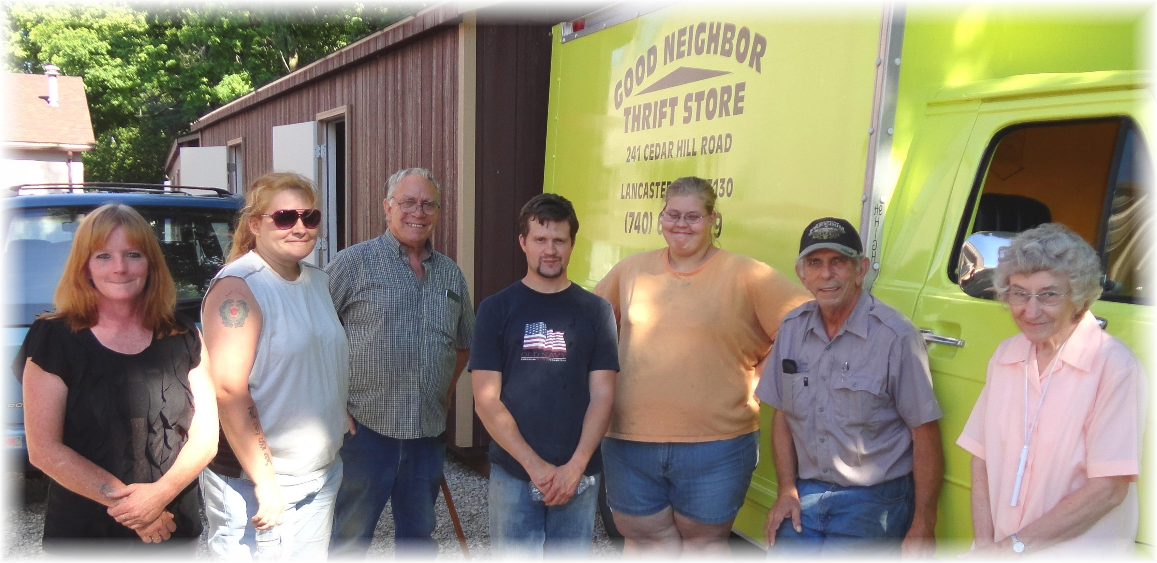
Lorie, Lisa, Tom, Allen, Jennifer, John, Freda
Good Neighbor Thrift Store – June 13, 2012

