Lancaster Seventh-Day Adventist Church
A House of Prayer for All People
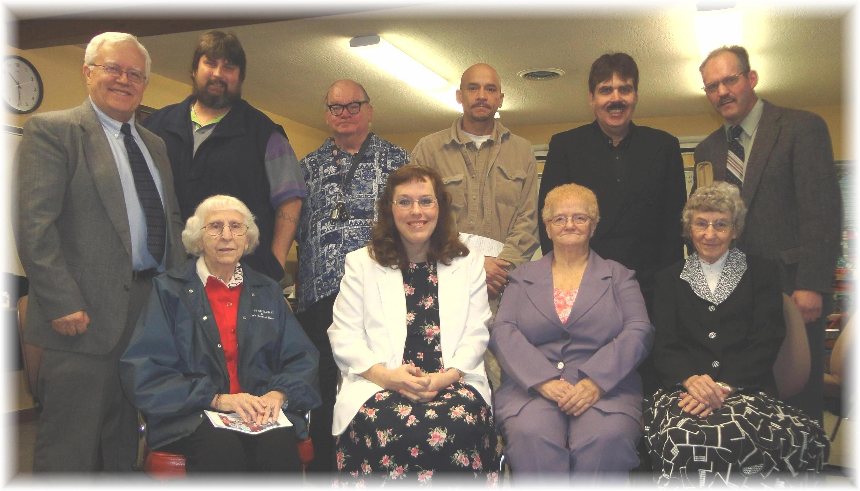
Al, Willy, Tom, Jason, Carlton, Andy
Edith, Carol, Sandy, Freda
New Believers Sabbath School Class – 2012

