Lancaster Seventh-Day Adventist Church
A House of Prayer for All People

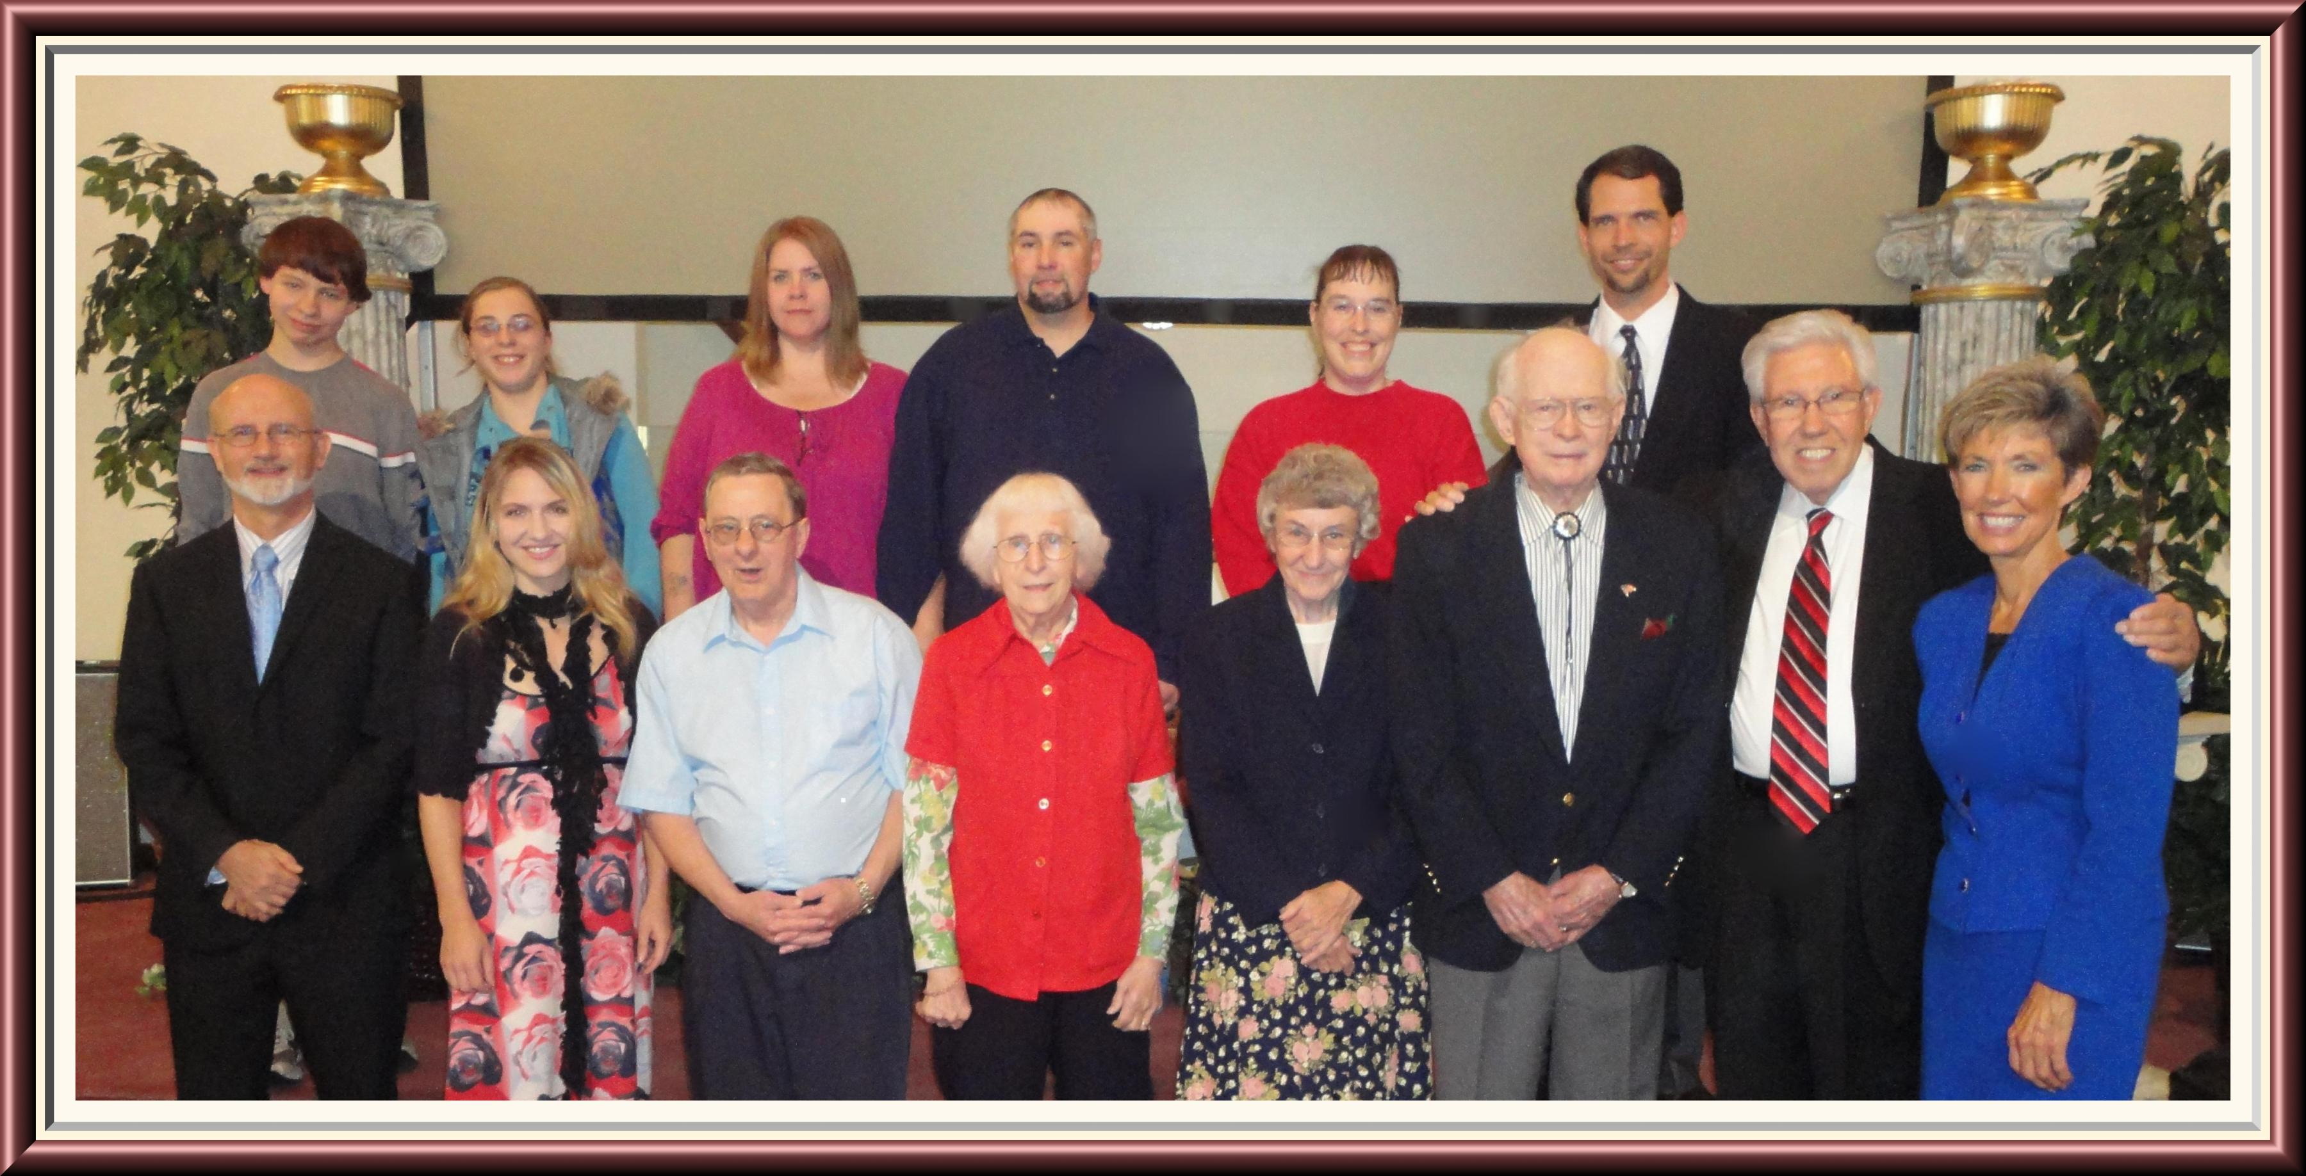
Back Row: Tyler, Sarah, Andrea, Rob, Carol, Travis Dean
Front Row: Pastor Mike, Trina, David, Edith, Freda, Ralph, Elder Ken Cox, Dona
Lancaster S.D.A. Church Baptisms - October 29, 2011

