Lancaster Seventh-Day Adventist Church
A House of Prayer for All People

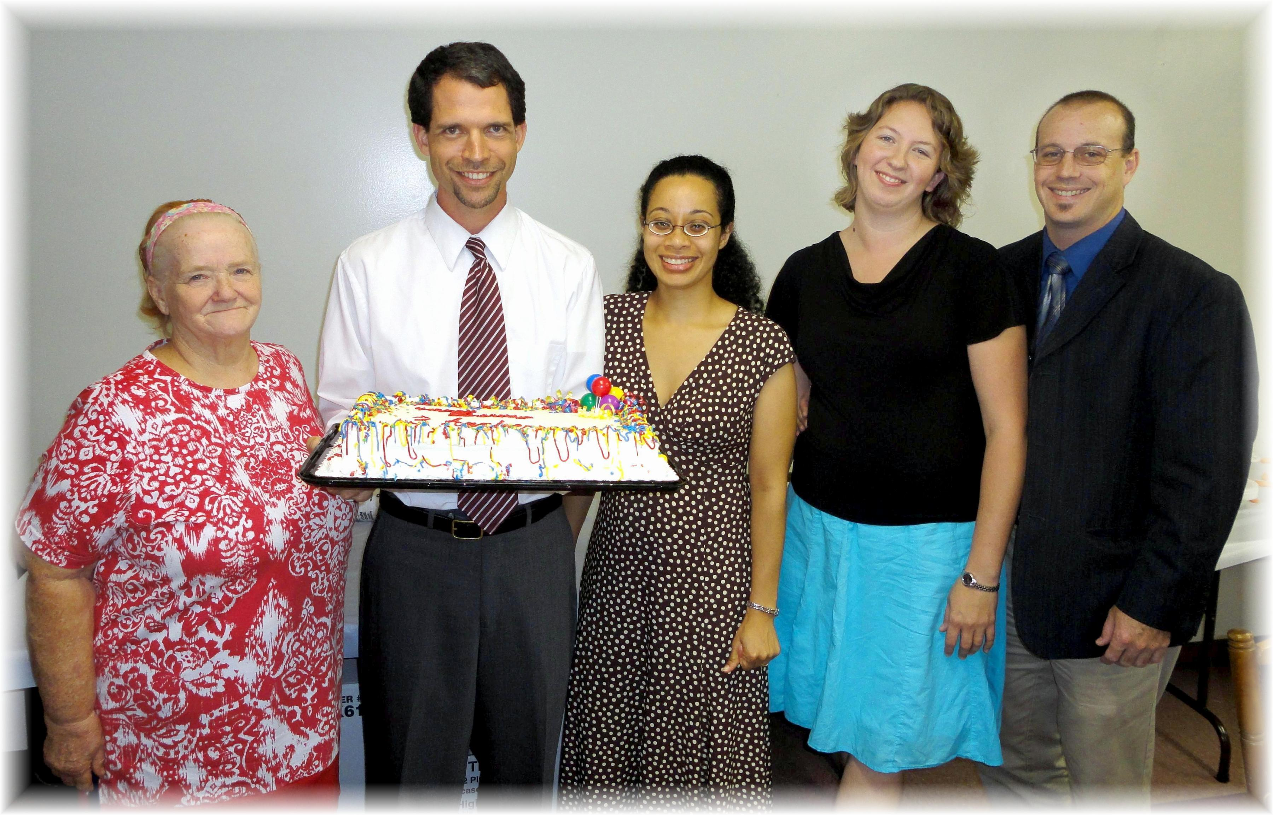
Sandy Hoover, Travis & Cesilia Dean, Jennifer & Anthony Southard
September Anniversaries - 2011

