Lancaster Seventh-Day Adventist Church
A House of Prayer for All People

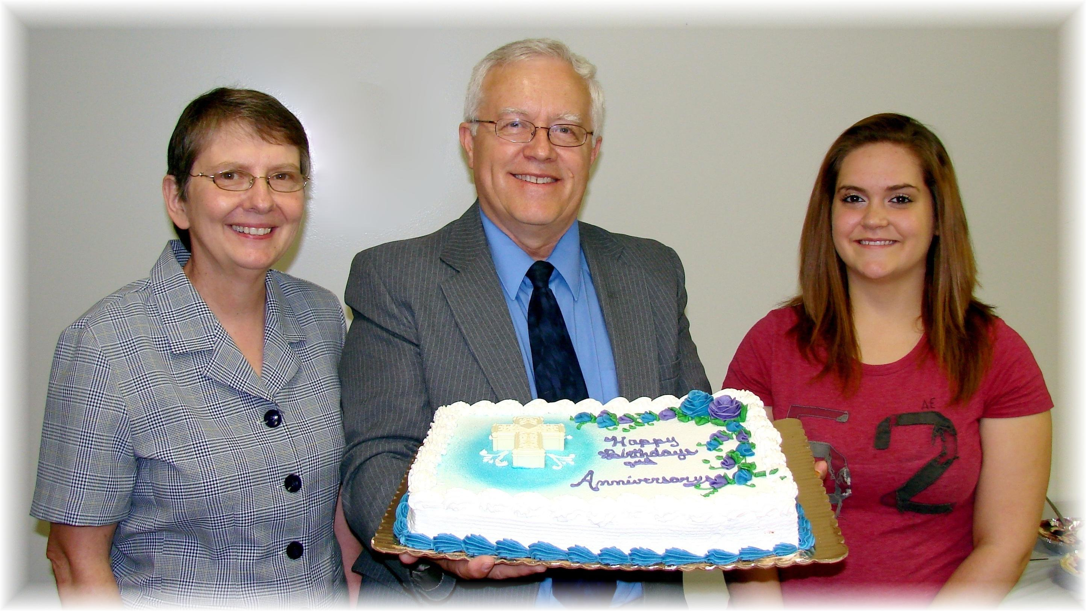
Anniversary: Bonnie and Al Birthday: Jaydayle.
Birthday and Anniversary – June, 2011

