Lancaster Seventh-Day Adventist Church
A House of Prayer for All People

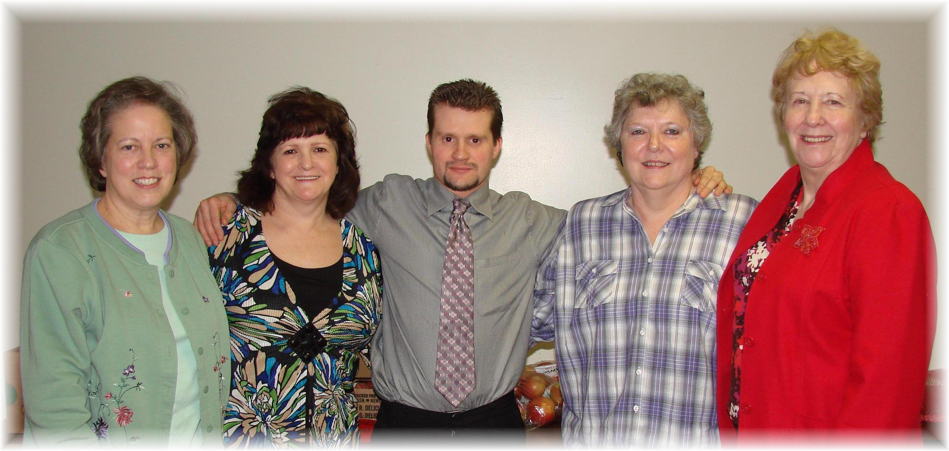
Health Ministries Team - 2011

