Lancaster Seventh-Day Adventist Church
A House of Prayer for All People

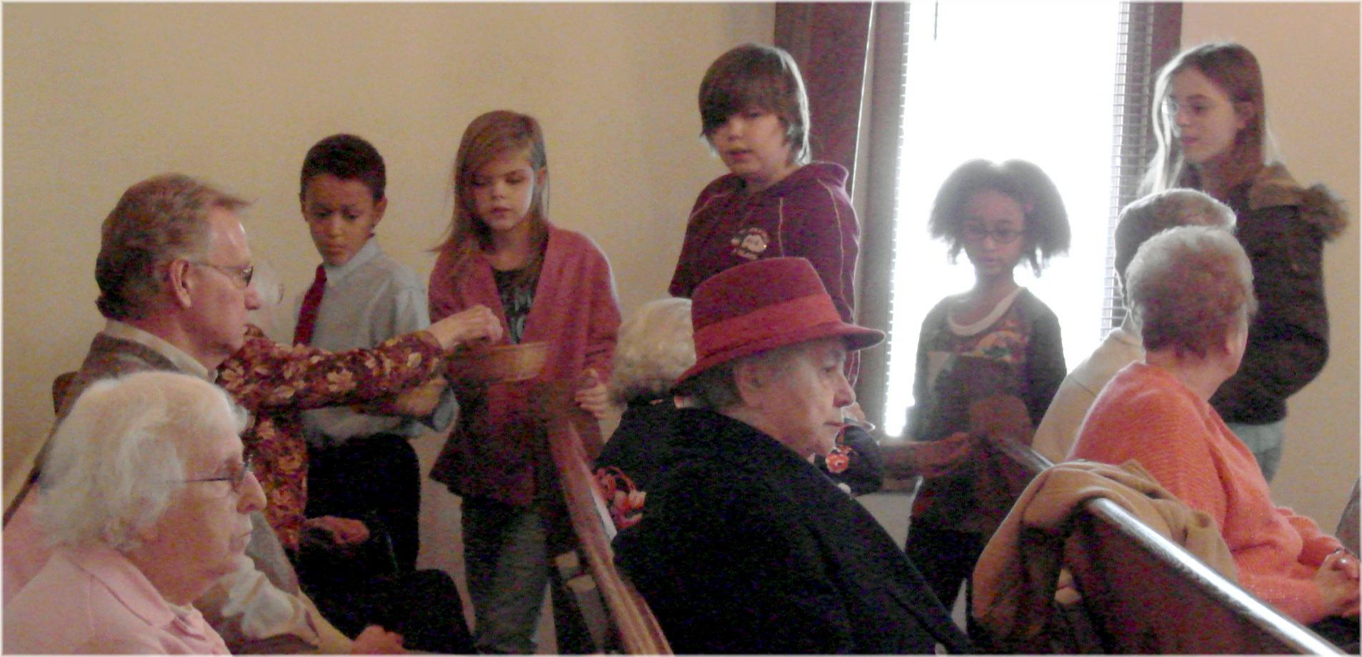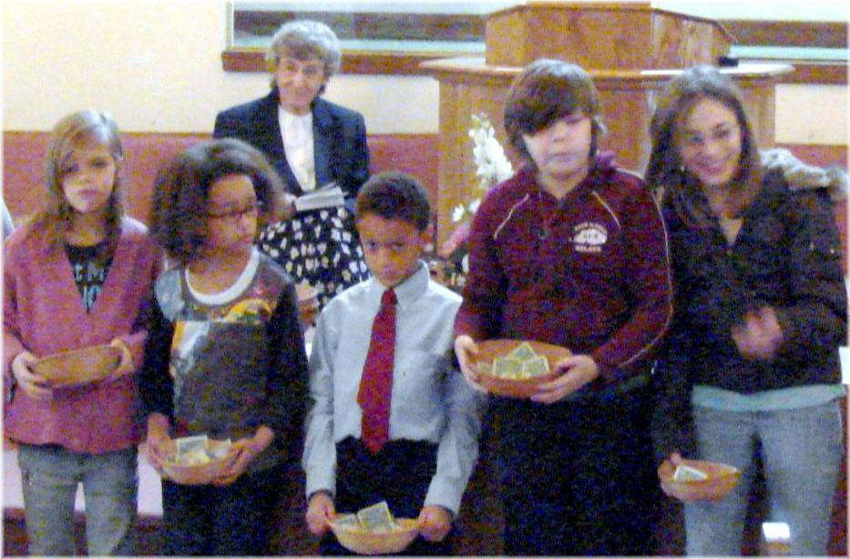

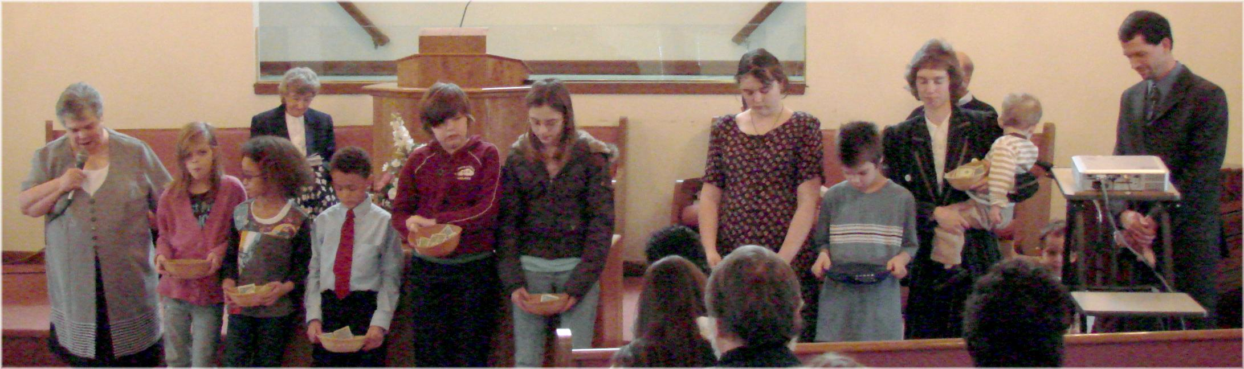
Children’s Offering - 2010

