Lancaster Seventh-Day Adventist Church
A House of Prayer for All People

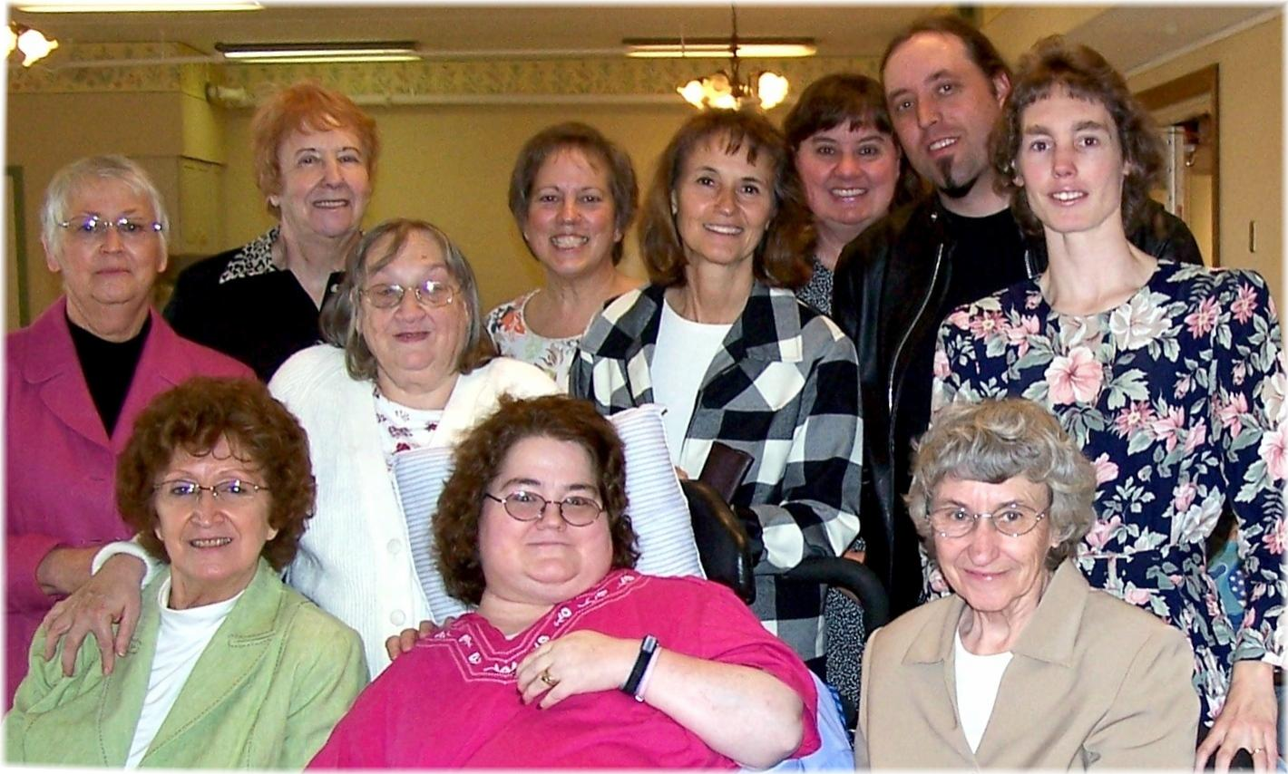
Nursing Home Visit – November 14, 2009

