Lancaster Seventh-Day Adventist Church
A House of Prayer for All People

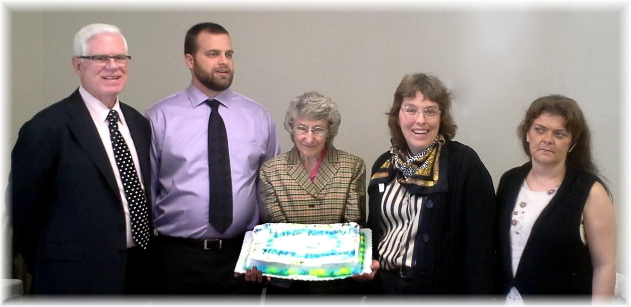
May Birthdays and Anniversaries – 2015

